**WEB-BASED MANAGEMENT INFORMATION SYSTEM FOR MALOLOS REGIONAL TRIAL COURT BRANCH NO. XVIII**

A Capstone Project Presented to the Faculty of the

College of Information and Communications Technology

Bulacan State University

City of Malolos, Bulacan

In Partial Fulfillment of the Requirements for the Degree

Bachelor of Science in Information Technology

By:

**Raymart S. Arceo**

**Jericho M. Batac**

**Gerald S. Colina**

**Kayeleigh C. Luluquisin**

**Aries Carlo L. Santos**

November 2022

**APPROVAL SHEET**

In partial fulfillment of the requirements for the degree of Bachelor of Science in Information Technology, this capstone project entitled “**WEB-BASED MANAGEMENT INFORMATION SYSTEM FOR MALOLOS REGIONAL TRIAL COURT BRANCH NO. XVIII**” has been prepared and submitted by **Raymart S. Arceo, Jericho M. Batac, Gerald S. Colina, Kayeleigh C. Luluquisin** and **Aries Carlo L. Santos** who are hereby recommended for an oral examination.

**MA. RUBY ANGELA J. CRISOSTOMO, MSIT**

Adviser

Approved in partial fulfillment of the requirements for the degree of Bachelor of Science in Information Technology by the Committee on Oral Examination.

|  |  |
| --- | --- |
| **JOHN MICHAEL D. CALIZON, MIEAE, MIET, MIEMT, MAET, GCE, SFCTM, SSYBTM, CASFTM, LFPCTM, CSFPCTM, RWVCPCTM, LLL, ACE, NSE**  Critic, Member | **ENGR. LESTER PHIL M. CRUZ, MSCPE**  Critic, Member |
| **RENATO L. ADRIANO, II, MSIT**  Critic, Chairman | **AARON PAUL M. DELA ROSA, MSIT, GK-CDPO, PCEP, JSE, CPE, CLE, ITS, MIE, GCE, DEL**  Capstone Project Coordinator |

Accepted in partial fulfillment of the requirements for the degree of Bachelor of Science in Information Technology.

|  |  |
| --- | --- |
| **GABRIEL M. GALANG, MSIT, GK-CDPO, PCEP, CLE**  Area Chair, Web and Mobile Applications Development Specialization Track | **DIGNA S. EVALE, DIT**  Department Head, BSIT |
| **KENO C. PIAD, DIT**  College Dean | |

November 2022

**ACKNOWLEDGEMENT**

“For I know the plans I have for you,” declares the Lord, “plans to prosper you and not to harm you, plans to give you hope and a future.” – (Jeremiah 29:11)

Without the assistance of the Almighty God, who has provided insight, strength, patience, and provision during the course of this study, the researcher would not be able to complete it. The researchers have gotten a big amount of support and help during the preparation of this study and development of the system.

This study would not been possible without the valuable help from the following individuals. To Mr. Roderick C. Cantaros and Mr. Aaron Paul M. Dela Rosa who serve as the thesis advisor for the researchers, their respective efforts in giving valuable inputs and comments elevated the quality of this study. To Mrs. Ma. Ruby Angela Crisostomo, for her valuable inputs and guidance throughout the development of the system and writing process of this paper, her contributions made this project possible. To Mr. James Perez, for his inputs and guidance that further elevated the quality of this project. For Mrs. Marian Minneli Cruz and her suggestions and inputs that gave the researchers even more ideas that upgraded the quality of the system. To Mr. Lester Phil Cruz, John Michael Calizon and Mr. Renato Adriano who serve as the project critics, their comments and suggestions gave even more quality to this project.

To the family and friends of the researchers who gave valuable support and encouragements that pushed the researchers to do their very best, their presence served as a significant factor in the success of this project.

C.L.A.B.S.

**DEDICATION**

I devotedly dedicate this work to my parents, Arnel and Norwina Arceo, for being supportive and whose sacrifices pushed me to do my best at everything including this project. Their love and support will always be my greatest source of motivation to be the best I can be.

I also dedicate this work to my friends who provided me valuable acts of encouragement and support whenever I feel uninspired and worried, their presence and love always remind me that I always people that I can lean on and who always believe in me.

*R.S. Arceo*

Wholeheartedly, I dedicate this work to my parents, Judith and Enrico Batac, for being supportive throughout the development of this thesis. They were, are, and always will be my inspiration to make all my works successful.

I also dedicate this work to the one who inspires and motivates me the most, Janelle Jacinto my girlfriend, who’s always there supporting me to do my thesis, for being the person who calms me every time I feel discouraged, and for being there always to cheer me up.

Last but not the least, to the one above all of us, the omnipresent God for hearing my prayers and providing me the courage to complete this challenging thesis. Thank you so much Lord.

*J. M. Batac*

Wholeheartedly, I dedicate this work to my parents, Merlita Colina and Gimbert Colina, for being supportive parents throughout the development of this thesis. Their always give me an advice that enjoy and focus my dreams in life.

I also dedicate this work to the one who inspires and motivates me the most, AC Manansala, who's always there to supporting me to do my thesis, for being the person who always calm me every time I feel down, the one who always to motivate to do things and believing me that I can do.

Lastly to my friends that help me a lot, and always supporting me for all my goals in life.

*G.S. Colina*

First and foremost, I want to dedicate this work to our Almighty Lord that have provided us the strength, knowledge, wisdom, patience and also because He gave me such incredible groupmates that never ever gave up on me even at difficult times.

With so much love and gratitude, I also want to dedicate this work to my family especially to my mother, Jenny Luluquisin, and my lola Leonida Catanghal, whom showed me so much support from the very start of this thesis. They were, are, and always will be my inspiration to make all my works successful.

Lastly, I would like to dedicate this work to our adviser Ma’am Ma. Ruby Angela J. Crisostomo for helping us and giving us advices since the very beginning. And to everyone who were willingly helped us throughout the making, and developing of this paper, as well as the system itself. Your love and support were all appreciated. Thank you!

*K.C. Luluquisin*

I wholeheartedly dedicate this work to my parents, Rosalie and Agripino Santos, for being supportive throughout the development of this thesis. They were, are, and will always be my motivation for the success of all my endeavors.

I also want to dedicate this work to our adviser Ma. Ruby Angela J. Crisostomo, who have been helpful during the developments of this thesis and for always being there to give us assistance.

*A.C.L. Santos*

**ABSTRACT**

Malolos Regional Trial Court branch XVIII (MRTC XVIII) is an institution that handles sensitive information and originally do so by the use of outdated and less-secure way. This study was conducted to determine the issues encountered by the institution and to describe the effectiveness of implementing new ways to manage information. To address the discovered problems, the researchers developed a web-based management information system to efficiently and effectively handle different types of information that the organization is responsible for. The system includes managing of case, employee records report generation and calendar features that will help to better accomplish tasks within the institution. This study also gave consideration to the software quality criteria as defined in the ISO/IEC 25010:2011 to ensure the system’s quality of service. The researchers conducted surveys involving technical experts and employees of MRTC XVIII and with the help of the evaluation from the mentioned group of people, the objective of the study was acquired. Descriptive methodology was utilized for this study as it is what more applicable for interpreting the respondents’ perspective towards the system’ effectiveness. The researchers utilized the Agile Software Development methodology that allowed seamless collaboration and efficient project management. Using research instruments, summarization of findings was done, the study gained an overall descriptive rating of Very Good which indicates that the system met the expectations and deemed effective by users and field experts.

**TABLE OF CONTENTS**

**Page**

|  |  |
| --- | --- |
| **TITLE** **PAGE** …………………………………………………………………....... | i |
| **APPROVAL SHEET** ……………………………………………………………... | ii |
| **ACKNOWLEDGEMENT** ……………………………………………………….. | iii |
| **DEDICATION** ……………………………………………………………………. | iv |
| **ABSTRACT** ……………………………………………………………………….. | vi |
| **TABLE OF CONTENTS** ………………………………………………………… | vii |
| **LIST OF TABLES** ………………………………………………………………... | ix |
| **LIST OF FIGURES** ……………………………………………………………… | x |
| **LIST OF APPENDICES** ………………………………………………………… | xii |

**CHAPTERS**

|  |  |  |
| --- | --- | --- |
| **I.** | **THE PROBLEM AND ITS BACKGROUND** |  |
|  | Introduction …………………………………………………….......... | 1 |
|  | Project Objectives ………………………………………..………….. | 3 |
|  | Purpose and Description ……………………………………………... | 4 |
|  | Scope and Limitations ……………………………..……..….............. | 5 |
| **II.** | **REVIEW OF RELATED LITERATURE/SYSTEMS** |  |
|  | Related Literature…………………………………………………… | 7 |
|  | Related Systems ….…………………………………………….…… | 11 |
|  | Conceptual Framework ……………………………………………… | 17 |
| **III.** | **TECHNICAL BACKGROUND** |  |
|  | Research Methodology ……………...………………………………. | 18 |
|  | Software Development Methodology………………………...……… | 19 |
|  | Requirements Analysis and Documentation………….………........... | 22 |
|  | System/Technical Requirement……………………………………… | 22 |
|  | Design of Software, Systems, Product, and/or Processes….………… | 24 |
|  | Development and Testing ……………………………………………. | 42 |
|  | Description of the Prototype …………………………………………. | 45 |
| **IV.** | **RESULTS AND DISCUSSION** |  |
|  | Design a Management Information System based on the clients’ requirements……………………………………...………………. | 64 |
|  | Determining the acceptability of the system using the ISO/IEC 25010:2011 software quality evaluation criteria as perceived by the  respondent………………………………………………………... | 68 |
| **V.** | **SUMMARY AND RECOMMENDATIONS** |  |
|  | Summary of Findings ……………………………………………….. | 78 |
|  | Conclusions ………………………………………………………….. | 79 |
|  | Recommendations …………………………………………………… | 80 |
|  | Research Implications ………………………………………………. | 80 |
| **BIBLIOGRAPHY** ………………………………………………………………… | | 82 |
| **APPENDICES** …………………………………………………………………….. | | 88 |

**LIST OF TABLES**

**Table Page**

|  |  |  |
| --- | --- | --- |
| 1 | Software Requirements of End Users………………………………….……. | 23 |
| 2 | Hardware Requirements of End Users ……………...………………………. | 23 |
| 3 | Hardware Requirements ……………………………………………………. | 24 |
| 4 | Respondents of Evaluation ……………………………………..…………… | 43 |
| 5 | Five Point Likert Type Attitude Scale……………………………………….. | 44 |
| 6 | Frequency Distribution and Descriptive Measures of the Respondents’ Ratings to the system in Terms of Functional Suitability ……………. | 69 |
| 7 | Frequency Distribution and Descriptive Measures of the Respondents’ Ratings to the system in Terms of Performance Efficiency …………. | 70 |
| 8 | Frequency Distribution and Descriptive Measures of the Respondents’ Ratings to the system in Terms of Compatibility ……………..……... | 71 |
| 9 | Frequency Distribution and Descriptive Measures of the Respondents’ Ratings to the system in Terms of Usability ………..……………….. | 72 |
| 10 | Frequency Distribution and Descriptive Measures of the Respondents’ Ratings to the system in Terms of Reliability .…………………..…... | 73 |
| 11 | Frequency Distribution and Descriptive Measures of the Respondents’ Ratings to the system in Terms of Security ………………………….. | 74 |
| 12 | Frequency Distribution and Descriptive Measures of the Respondents’ Ratings to the system in Terms of Maintainability ………………….. | 75 |
| 13 | Frequency Distribution and Descriptive Measures of the Respondents’ Ratings to the system in Terms of Portability…..……………………. | 76 |

**LIST OF FIGURES**

**Figure Page**

|  |  |  |
| --- | --- | --- |
| 1 | The Input Process Output (IPO) Framework …………………………….... | 17 |
| 2 | Agile Software Development Life Cycle ………………..……………..…. | 20 |
| 3 | Landing Page Flowchart …….…………………………………………….. | 25 |
| 4 | Log In Flowchart ……………………...……………...……………............ | 26 |
| 5 | Admin Landing Page Flowchart ………………………………….………. | 27 |
| 6 | Admin Account Details ………………………….....……………………... | 28 |
| 7 | Admin Dashboard Flowchart ………………….………….……………….. | 29 |
| 8 | Admin Calendar Flowchart ……………………………………….……….. | 30 |
| 9.1 | Admin Cases Flowchart 1 ………………………...……………………….. | 31 |
| 9.2 | Admin Cases Flowchart 2 ………………………...……………………….. | 32 |
| 10 | Admin Accounts Page Flowchart …………………….…………………… | 33 |
| 11 | Activity Page Flowchart …………………………………………………… | 34 |
| 12 | Employee Landing Page Flowchart ………………………………………. | 35 |
| 13 | Employee Dashboard Flowchart ……………………..…………………… | 36 |
| 14 | Employee Calendar Flowchart ……………………………………………. | 37 |
| 15.1 | Employee Cases Flowchart ………………………………………………... | 38 |
| 15.2 | Employee Cases Flowchart ………………………………………………... | 39 |
| 16 | Employee Profile Flowchart ………………………………………………. | 40 |
| 17 | Entity Relationship Diagram ……………………………………………..... | 41 |
| 18 | Software Quality Evaluation …………………………………………….… | 42 |
| 19 | Guest Home Page ……………………………………………………..…… | 45 |
| 20 | Guest Court Schedule …………………………………………………….... | 46 |
| 21 | About Us Page ……………………………………………..……………… | 47 |
| 22 | Login Page ………………………………………………………………… | 48 |
| 23 | Admin Dashboard ……………..…………………………….……………. | 49 |
| 24 | Admin Calendar ……………………………………………………….…... | 50 |
| 25 | Admin Case Management …………………………………………………. | 51 |
| 26 | Add Case Form ………..………………………………………………….. | 52 |
| 27 | View Case Form ……………………………………………………….…. | 53 |
| 28 | Edit Case Form ……………………………………………….…………... | 54 |
| 29 | Report File Format ……………………………..…………………………. | 55 |
| 30 | Report Generation ………………………………………………………… | 56 |
| 31 | Account Page ……………………………………………………………... | 57 |
| 32 | Add Account Form ………………………………………………………… | 58 |
| 33 | Accounts Activity Logs …………………………………………………… | 59 |
| 34 | Employee Home Page …………………………………………………….. | 60 |
| 35 | Employees Case Management …………………………………………..... | 61 |
| 36 | Employees View Case Page ………………………………….…………… | 62 |
| 37 | Employees Calendar ……………………………………………...……….. | 63 |
| 38 | System’s Log-In Page ………………………………………...…………… | 65 |
| 39 | Case Management Tab ……………………………………………..…....... | 66 |
| 40 | System’s Report Generation Feature ……………………………………… | 67 |
| 41 | System’s Calendar …………………………………………………………. | 68 |

**LIST OF APPENDICES**

**Appendix Page**

|  |  |  |
| --- | --- | --- |
| A | Communications Letters ..……………………………………………... | 88 |
| B | Relevant Source Code …………………………………………………. | 95 |
| C | Research Instruments ………………………………………………….. | 112 |
| D | Plagiarism Check Certificate ………………………………………….. | 123 |
| E | IMRaD Format ………………………………………………………… | 125 |
| F | One-page Curriculum Vitae …………………………………………… | 127 |

**Chapter I**

**INTRODUCTION**

**Project Context**

In the modern and present day, managing record does not end in just simply keeping them, for an organization to effectively handle and protect their client`s data as well as their own, implementing modern and practical approach would of significant help and worth investing for Ludlow (2018). However, based on the present Covid pandemic, remote access to papers and files has become absolutely necessary, particularly in connection to internal operations. Records should be securely, traceably, and irreversibly archived for access in the future. Gelashvili and Pappel (2021).  Data privacy and confidentiality undeniably plays a significant role in almost every type of organization and judicial organizations are no exception as they handle countless sensitive information.

Using traditional methods of record-keeping presents some serious issues that can easily be addressed with the help of modern technology as Americanbar (2013) stated in an article. The eCourt system is a component of the Philippine Supreme Court's initiative to improve court efficiency and transparency by lessening administrative burdens on court workers and facilitating easy access to case information for attorneys and plaintiffs. The eCourt, according to Chief Justice Sereno, will expedite judicial procedures, get rid of potential corruption hotspots, and assure greater openness., the statement further proves that the approaches that judicial organizations are using are lacking features that can stand be a long-term solution Americanbar (2013).

Malolos Regional Trial Court Branch No. XVII is a courthouse situated in Guinhawa, City of Malolos, Bulacan that has been handling cases such as criminal or civil, its on-going proceedings as well as giving judgements to those accused, monitoring and generating monthly reports about the collected data of those person who are in trial that is being required by the Supreme Court. Inside the institution, work related to handling serious and sensitive cases and all information about those cases is a consistent routine. The courthouse is geared towards giving the community a quality and clean judicial related service. In order to keep doing so, the Malolos Regional Trial Court continues seeking methods and approaches that would further enable them to effectively play the role they are expected to fulfil.

With the help of a spread sheet application, Malolos Regional Trial Court Branch No. XVII can accomplish day-to-day tasks of keeping and handling internal records however, with effort that the current method requires and with its lack of security the employees of the institution feel the need for an improvement that could be given by a modern, efficient, and much effective approach. CLABS is a system that enables its users to access information such as proceedings schedules, view, add, edit, or archive inserted cases, and will be able to have an overview of the data inside the system.

To address the stated issues, the system provided features that offer practical solutions. Proper utilization of the database was used to cover the needs for an organized way of storing information. To give importance to the security aspect, the system introduced a feature that will keep track of all the activities done within the system and the usage of database will serve an important role in ensuring that the information is being stored with regards to security.

**Project Objectives**

**General Objective**

The main purpose of the study is to develop a Web-based Management Information System for Malolos Regional Trial Court as an efficient, effective, and modern approach of managing information.

**Specific Objectives**

Specifically, this study aims:

1. To design a management information system with the following features:
   1. Secure storage of information;
   2. Record management;
   3. Report generation; and
   4. Calendar.
2. To determine the acceptability of the system using the ISO/IEC 25010:2011 software quality evaluation criteria as perceived by the respondents on the following:
   1. Functional Sustainability;
   2. Performance Efficiency;
   3. Compatibility;
   4. Usability;
   5. Security;
   6. Reliability;
   7. Maintainability; and
   8. Portability.

**Purpose and Description**

The purpose of this system is to provide various tools and functions, including report generation feature and an integrated calendar that would eliminate all hassle in accomplishing the task of effectively keeping and managing records of information.

As the target beneficiary of this research is the field of the judiciary, they are expected to have a high consideration with all the information that they handle, and with the help of this system, employees and the institution can assure that they have the best feasible way keeping and managing information that would lead to the overall success of their organization. This study aims to be of significance to the following:

**Malolos Regional Trial Court.** With the implementation of this system, the day-to-day flow inside Malolos Regional Trial Court would be much smoother that it used to be, as this system will offer a secure and faster way of managing information that would lead to a much efficient accomplishment of each task inside the institution and therefore would enable them to be more productive while being efficient in terms of time and other resources. Having an efficient and effective business process would also help the institution to further solidify their brand that would result in clients having significantly greater sense of trust and confidence with the institution and its service. With the tasks being faster and more efficient, employees of Malolos Regional Trial Court would experience a much lighter and less stressful experience inside their workplace making them happier and satisfied that would then lead to a vast experience for everyone inside the premises of the institution. Furthermore, with the security that the system offers, employees would possess confidence in accomplishing each task that would make them function better.

**Researchers in the Field of Information Technology.** this study contains information that have been helpful in the development of project itself, but that information is not limited to any specific project, with the conclusions that this paper has drawn, future researcher will be able to gain insight that are founded using credible sources that they can later use to initiate a new study that can further improve the way of the existing approach. Using this paper, future researchers can also give themselves a chance to design and produce new and innovative ways that would pave the way for another set of future researchers to discover further improvements that will make everyone' live a little easier that before.

**Scope and Limitations**

This research focuses on creating a management information system with a built-in report generator and calendar. This study will enhance the Malolos Regional Trial Court's present workflow and propose a different strategy for managing information effectively.

This Information System is specifically developed for the service of Malolos Regional Trial Court and therefore would be able to manage the information within the said institution. This system offers a user-friendly interface that leads to an intuitive way of creating, reading, updating, and archiving records, additionally, this system implements a platform to easily create well-structured reports which can be a soft copy or hard copy, however, this system does not lude fully automated report generation which means the employees would still need to explicitly tell the system what the reports would look like, with this fact, the employees would be able to ensure that the system will generate an expected output.

This system offers a built-in calendar that will service the employees within Malolos Regional Trial Court, this feature will help the employees on keeping track of all the schedule related to the organization and this would also lessen the workload of employees especially the secretary as the system would be the one that is responsible in informing someone about an incoming schedule. Although the system will automatically notify employees, this system does not cater automated adding of schedules in the calendar, one employee would still need to add a specific date and time of an event.

**Chapter II**

**REVIEW OF RELATED LITERATURE/SYSTEMS**

This chapter focuses on gathering theories that relate to the current study. It serves as a foundation and guide to deeply understand the system as a whole and especially be familiar to Management Information Systems. It also reviews related concepts, principles, and studies that were relevant to analyzing the topic and serves as a guide for assessing relationships between aspects affecting the study. This contains the study's conceptual principles, research framework, and term definitions. Information was gathered through many media, including books, newspapers, and the internet. The primary objective of the literature review was to look at prior studies on knowledge sharing. This was done as part of the emergent research design process to sketch out the essential data gathering requirements for the primary study to be conducted.

**Related Literature**

**Development of Management Information System**

The IT revolution brought significant advantages in every institution of any field and these advantages has been proven to improve organizational processes that had led to success, however these advancements also presented vulnerabilities that made the corporate world realize that security is another thing to consider and prioritize in able to achieve greater success Pereira et al (2017). Data is the most vital assets of any organization as it serves as its foundation to create meaningful information and knowledge as well as a guide to come up with better business-related decisions and action, furthermore, proper data storage and processing are essential for an organization to upgrade their performance Singh, et al (2021). As technology continuously evolve, the need and role of Information Security practitioners become more complex as these technology advancements also brought new and much challenging threats in an organization’ business processes Burdon and Coles-Kemp (2019). In a study by Orbeta et al (2021). It was proven that implementing an e-court system that holds capabilities to securely and effectively store information among other features brings significant advantages that contribute to the improvement of workflow.

Records management is the process systematic and efficient creation and maintenance of information handled by an organization; these information serves an integral role in keeping track of the activities inside an institution United Nations Archieves (n.d). To highlight the importance of good record management. Tasnim et al (2018) stated that usage effective and secure ways to manage records can help an institution maintain data integrity by setting information keeping structures that effectively eliminates chances of tampering and other anomalies in organizational data and therefore giving clients additional level confidence in the integrity of an organization’ services. Moreover, Ukaogba and Nwankwo (2020) have determined that it is important for an organization to properly handle information throughout its lifetime, when records are well-created, properly stored and properly achieved, the execution of major organizational tasks is likely to be easy. The readiness of record management in an organization is determined by the practices, the record management practices of should adapt to the organization’ environment for an efficient and practical results Mohamed and Bunawan (2022). In an article by Jayoma et al (2020) the significant improvement brought by modern technologies for record keeping were highlighted, implementations of these technologies enable organization to maintain the accessibility information even for future purposes, this modern way of record management also furtherly proves that the conventional methods consist of undeniable drawbacks that put an organization to various risks.

According to indeed.com (2021) generating reports about an organization’ data greatly helps the institution to get a wide insight of the different information that come into their workflow, having broader view of these data also allow them to make analysis and realizations. Additionally, Wang et al (2019) found out that producing well-organized and accurate reports together with other report generation scheme to further improve data summarization can greatly improve the perspective of people that lead to even better decision-making. Additionally, Barrantes (n.d) was able to conclude that usage if new technologies in creating reports adds another level of sophistication as modern way of creating reports allows users to generate complex reports depending on their needs which then leads to better analysis of organization-related information.

In an article shared by Sloan (2018) it was determined that implementing a calendar in a bigger system allows the users to benefit from several advantages. A calendar system improves time management and prioritization of tasks within an institution, these things among other factors contribute in achieving organizational duties and goals. Implementing a schedule management tool such as calendar makes various tasks like adapting to schedule changes and tracking current and future activities easier and this tools also enhances communication within the organization that is essential in achieving a common goal Hughes (2019). Additionally, Wrike.com (n.d) stated that implementing a calendar functionality in a system eliminates unnecessary confusions about a certain thing inside an institution, by using electronic calendars, all activities are being track and other factors are being closely monitored.

With the stated facts above, the researchers come up with a system that will give as much advantages to the target organization by eliminating as much risks as possible. An institution who owns a system that consists of essential tools like report creation and a dedicated calendar will enable the organization to achieve their full potential and will enable them to deliver quality services to their valued clients.

**Level of acceptability with accordance to Standard Software Quality Evaluation Criteria**

Acceptance testing activity focuses on ensuring that a software product is within the expectations and acceptance level of users. This phase of testing aims to scan the system’ Functional Sustainability, Performance Efficiency among other factors, prioritizations of these criteria will determine whether the system will be released for the service of the clients or users Software Testing Fundamentals (2022). Additionally, Lestantri and Rosini (2018) mentioned that before releasing a software to the public, it needs to pass quality testing to ensure that it meets the users’ needs and it will bring nothing less than convenience. Organization must put great prioritization towards software quality as it determines the success or failure of an institution. To further present the advantages of evaluating software quality, Villones (2021) shared relevant results, in here article it was revealed that proper execution of software evaluation can result in high satisfactory level for users and it bring some valuable and long-term advantages to organizations, prioritizing things like Maintainability, Security among other factors was proven to save resources and improve an institution’ image and credibility.

With the help of related resources above, the researchers got a clearer perspective of the factors to consider when developing a software product, these new ideas and knowledge will help the developers to produce a highly acceptable product that will not only bring satisfaction to the users but also elevate the developers’ capabilities to create quality products in the future that will benefit larger number of people.

**Related Systems**

**Web-based Barangay Information System**

The purpose of this study by Bondoc (2019) This research aims to develop a web-based barangay information system called "eBarangay" for barangay manga in San Isidro, Nueva Ecija. Researchers have applied research development methods to the design and development of web-based barangay information systems. E-Barangay was developed using the Systems Development Lifecycle (SDLC) methodology and evaluated by IT (Information Technology) professionals.

The approval of the developed system was evaluated based on an international standard for software evaluation, also known as ISO 9126. The system complies with the standards set by ISO 9126 and has an average rating of 4.24 from IT professionals, which is equivalent to "Excellent". In addition, responses of the local officials from Barangay Communal municipality gave an average rating of 4.23. This is equivalent to "Excellent". The e-Barangay was considered acceptable because the respondents were satisfied with the features of the system and felt it was functional and user-friendly. This system is beneficial to Barangay Mangga in streamlining management processes and managing document requirements. By implementing the e-Barangay system, it also serves as a database of barangay local statistics.

Like the e-barangay system, this system also involves management of information of the institution with the use of database and processing methodologies. The information that this system handles are also used to generate useful reports that can give data visualization for the users and the management.

**Lawphil**

The Arellano Law Foundation in the Philippines has launched a project called Lawphil. The goal of the project is to make all Philippine laws, legislation, case law, presidential decrees, and other legal information available online. The site now offers full text copies of the 1987, 1973, 1935, and 1899 Malolos Constitutions, as well as selected Philippine legislation from 1900 onwards. From 1910 onwards, full text court judgements are available, which can be perused by year or searched using the site's search engine. Executive orders, general orders, and proclamations are among the other legal documents available on the site. There's also some background on the Philippine court system, such as court regulations and legal ethics. The Philippine Congress is discussed, as well as legal news and events and a directory of government agencies.

The handling of events as featured in this related system will be beneficial to the Malolos Regional Trial Court as it will allow them to keep track of schedules and can lead to efficient workflow. The ability to search and filter information within the system will also contribute to the overall functionality of the system.

**Paper-less Philippine Courts**

In the findings of a research which was geared to implement ways to improve record management in courts in the Philippines stated in an article by Camacho (2020), it was made clear that implementation of Court Records Management System in some high courts in the Philippines showed great signs of success right from the beginning. In the system’s pilot first round of reporting in 2017, the new method was utilized by over 85% of the trial courts across the country to report on criminal cases to the Supreme Court. Policymakers were able to closely monitor the Continuous Trial system's implementation thanks to the high participation rate. The Court Management Office, which co-developed the system, was able to use the substantial data from the system to highlight underperforming courts, spot bottlenecks in criminal processes, and respond to growing difficulties. Family court processes, local misdemeanor cases, and plea agreements policies have all benefited.

The implementation of the capabilities of the system featured by Camacho (2020), was determined to be beneficial to this paper' system because a modern way of managing records will decrease chances of errors and therefore will lead to more efficient and accurate outputs.

**PACER Public Access to Court Electronic Records**

It is an electronic public access service for federal court papers in the United States. Users can access case and docket information from US district courts, US courts of appeals, and US bankruptcy courts. The Administrative Office of the United States Courts administers the system in accordance with the directives of the Judicial Conference, which is chaired by the Chief Justice of the United States. It has more than 500 million papers as of 2013.

Each court has its own system, with only a small portion of data from each case being sent to the US. Each night, the PACER Service Center in San Antonio, Texas, hosts the Party/Case Index server. The Federal Judiciary's Case Management/Electronic Case Files (CM/ECF) system is used to send records to individual courts, and the courts' electronic court filing (e-filing) system normally accepts documents in the Portable Document Format (PDF). Each court has its own database including case information. Because each court maintains its own PACER database system, each authority will have its own URL.

Accepting digital formats for the purpose of keeping related information as featured in this related system will help the Malolos Regional Trial Court in terms of having multiple copies of information, which can further eliminate cases of data loss as these copies can serve as a backup.

**Court Record Management System**

In a study focusing on the utilization of Court Records Management System, it was revealed that embracing such technology led to better case file administration at the Gaborone Magisterial District, successful case file capture into the system, quicker case file retrieval, and a considerable decrease in lost and missing case file events. Challenges included shortcomings in the security of digital case files, digital records preservation and disposition, records appraisal, training, inadequate bandwidth, and shortage of computers, as well as inadequate archives and records management standards and guidelines Additionally, it was concluded that the results should help with the deployment of court records management systems in the African public sector in general and the judiciary especially in the future. Lessons learned can help other courts avoid the problems encountered when implementing CRMS. Mosweu and Kenosi (2018).

The features present in the paper by Mosweu and Kenosi (2018) can increase the overall process within the Malolos Regional Trial Court. Implementation of archiving information will help in recovering data that was previously removed from the primary records.

**Judicial System**

Ungar (2021) states on a chapter in his study looks at three broad contexts that influence its ability: independence, which reflects its ability to act as a check on elected officials and laws; authority and effectiveness, which reflects the impact of judicial rulings and actions in the jurisdictions where they are made; and citizen access, which measures the judiciary's ties to society. It uses these situations to illustrate the uncertainties in three case studies: corruption, organized crime, and the environment. Despite the fact that Latin American constitutions call for a balance of power among the three institutions of government - executive, legislative, and judiciary - the executive branch remains dominant. The introduction of judicial councils to select nominees for judgeships and other positions was another key reform, as the politicization of nominations had long been a primary reason of weak independence other positions, such as Attorney General, and, in many cases, to also oversee court functioning.

Being certain about the people involved in all the processes happening in an organization serves an integral role in keeping security in check. Inside this paper’ featured system, the users and the administrator are able to view the persons related to a specific case and thus making things transparent.

**Designing and Implementing e-Justice Systems**

On a study made by Benzar Glen Grepon (2021), computer-based information systems for case management are still at an early stage of adoption in many trial courts in the Philippines. In most cases, the information system implemented is the case docket using the official record book on which cases are written and inventory of cases and reports are generated. This is a standalone system that often faces data processing, data security and case management challenges. In numerous trial courts around the country, however, there are examples of information systems overcoming these difficulties and developing innovative solutions that surpass data management practices. The Regional Trial Court Branch 23 of Cagayan de Oro City in Northern Mindanao, Philippines, is one such instance. For the judicial branch, a project called Web-based Case Docket Information System (WCDIS) was created and implemented. This system follows the SDLC (System Development Life Cycle) structure, which is a design and development guide. The primary system capabilities and implementation methods are also discussed in this paper, as well as the merits and drawbacks of this strategy, with the purpose of applying lessons gained to future installations. The most notable achievement of this initiative is ability to increase efficiency and reliability in completing court transactions.

The benefits of having the features present in the system by Benzar Glen Grepon (2021), was proven to collectively be a major contributor for the betterment of the workflow inside an institution. All features found in this system will enable the Malolos Regional Trial Court to accomplish organization’ tasks with consideration with efficiency, performance and security among other important aspects.

**Conceptual Framework**

In order to give an overview of this study’ process of producing a planned output, the researchers used the Input-Process-Output (IPO) framework to translate the mentioned process into a visual representation. This representation will help the readers understand how collected data were processed to eventually come up with a solution for the problem that this paper is trying to solve.

**INPUT PROCESS OUTPUT**

* Data gathered from Malolos Regional Trial Court Branch No. XVIII.
* Review of Related Literature and Systems.
* Identification of tools needed for the development of the system.
* Secure and efficient Management Information system for Malolos Regional Trial Court Branch No. XVIII.
* Identifying the issues within the institution.
* Planning the flow and features for the system using various diagrams and planning-related documents.
* Development of the system using the identified development tools and methodologies.
* System evaluation using the ISO/IEC 25010.

**Figure 1. The Input Process Output (IPO) Framework**

**CHAPTER III**

**TECHNICAL BACKGROUND**

This chapter discusses methodologies, requirements, testing, and the procedures that will be used to carry out the study of Management Information System for Malolos Regional Trial Court. It contains information on the method used in carrying out this research and provides a justification for its use. In addition, a description of the prototype will be presented in order to visualize the project that will be developed.

**Research Methodology**

The exact steps or methods used to find, pick, process, and analyze information on a subject are known as research methodology. Providing the readers an overview of the methodology. Methods used in descriptive research outline the features of the variables being examined. With this methodology, the emphasis is more on providing answers to "what" questions than "why" questions about the study topic. Descriptive research is called an observational research method as none of the variables in the study are influenced during the process of the research Voxco (2021).

In order to deliver a solid information about the technology that the developers are trying to develop and produce a concise and well-structured information about the ins and outs of the system, the developers implemented the descriptive research approach. Descriptive research best fits for this study as this specific research methodology focuses on describing people’ perceptions or interpretation of the effectiveness of a certain development. To furtherly elaborate, this system intends to provide an alternative way of managing information inside a judicial firm and with the implementation of descriptive type of methodology, the researchers would be able to describe how this development would help to improve the workflow inside a judicial institution.

**Software Development Methodology**

Software Development Life Cycle (SDLC) is an industry standard use for defining the phases of a certain project being developed, SDLC ensures that a project will adhere the customers' expectations and that the developers will be able to provide a complete and high-quality product within the given timeframe and within the allotted budget.

Given the sensitivity of information that Malolos Regional trial Court handles and the ever-growing trend in the field of technology, the developers implemented the Agile methodology that will ensure that the system adheres with the standards and requirements of the institution. Agile methodology will allow the developers to deploy a system that is well-prepared for rapid changes of requirements and trends in the industry

Product development methodologies that adhere to the values and guiding principles of Agile Manifesto for software development are known as Agile methodologies. Agile techniques seek to produce the proper product by delivering small, regular chunks of functionality through cross-functional, small teams that self-organize, allowing for frequent customer feedback and course correction as necessary. Digite (n.d).

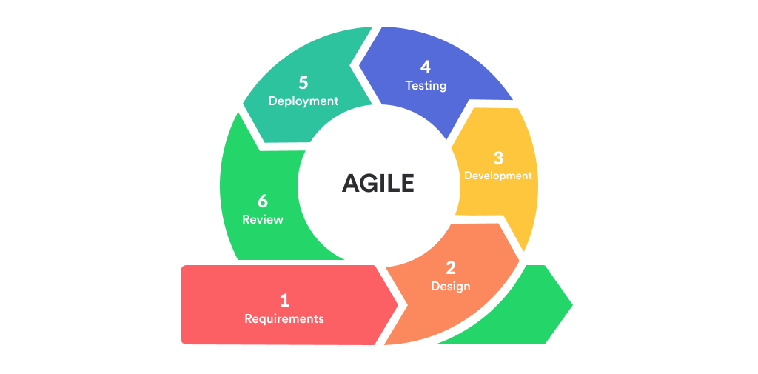

**Figure 2.** **Agile Software Development Life Cycle (ResearchGate)**

Image source from:

https://www.researchgate.net/figure/Agile-Methodology-in-System-Development-source-Okeke2021-retrieved-from_fig1_354310848

*Requirements Phase.* During this stage of the project, the researchers gather all the information regarding the features that the client needs for the system to have, throughout this phase, the researchers have been in full cooperation with the representative of Malolos Regional Trial Court to furtherly understand their demands. Together with gathering of information from the client, discussion about the distinct factors like developer’s timeframe, resources were also addressed to ensure a strong understanding between the client and the developers. In order to settle potential technical concerns, the developers ensured that technical and other requirements that the system would need are clearly explained so that the client would have a chance of assessing their institutions’ capabilities and limitations.

*Design phase.*Throughout this stage, the developers focused on discussing essential tools such as the programming languages to be used, frameworks, libraries and other related technologies constructing different visual representation such as data flow diagrams and flow chart to make an outline of the system’ required informational and physical specifications and features were also given priority. This phase helped the developers to have an abstract and concrete overview of the entire system.

*Development phase.*During this phase, the developers focused on writing codes using the chosen programming languages and tools. The tasks were divided into sections of developers in the group. The back-end developers addressed the needs for a well-functioning and smooth-flowing system and the front-end with coordination with back-end developers ensured that the users would have an efficient and valuable experience while using the system, lastly, the database administrators focused on encoding necessary information into the database. The development includes several iterations as the initial release is likely to undergo testing and changes to further improve the system.

*Integration and testing phase.*In this phase of the project, the researchers implemented various testing methods that ensured and verified that the system was able to meet the stated requirements. During this stage, the researchers have gone through checking of the systems’ functions and source code to spot any defects and possible weak points and developers will later implement solutions to address them, feedback from the users were also gathered during this stage. This stage played a vital part in the success of the system.

*Implementation and deployment.*In this stage, the complete, well-tested and approved version of the system was made available to the client. As this phase kicks in, the developers prepared on receiving further feedbacks from the users and provided actions with accordance to those feedbacks. In this phase the developers guide the users on how to operate the system, after this phase, the users are expected to have enough information on the ins and outs of the system.

*Review phase.*This stage focused on presenting the results of the latest completed development to the client. In this phase the developers will focus on presenting the accomplishments and goals achieved during the process of meeting the system’ requirements.

**Requirements Analysis and Documentation**

In this section, user and system requirements will be discussed. The findings of the requirements elicitation and analysis processes are also documented. For some needs, assessing the system is necessary and critical to the development of the application since it will reveal its flaws and allow you to make adjustments and suggestions to the proposed application's vital factors.

**System/Technical Requirements**

The hardware and software must meet the system's criteria for it to function properly. The creation of the system necessitates a few coding and program development requirements. These requirements determine whether the program succeeds or fails.

**Table 1**

**Software Requirements of End Users**

|  |  |  |
| --- | --- | --- |
| **Software Resources** | **Minimum requirements** | **Suggested requirements** |
| Operating System | Windows 8.1 | Windows 10 |
| System Type | 64 or 32 bit | 64 or 32 bit |

Table 1 shows the software requirements for the specified system's end users. To open the website, you must have at least Windows 8.1 installed, however Windows 10 is highly suggested to avoid any system issues.

**Table 2**

**Hardware Requirements of End Users**

|  |  |  |
| --- | --- | --- |
| **Hardware Requirements** | **Minimum requirements** | **Suggested requirements** |
| Processor | Intel Core i3 | Intel Core i5 |
| RAM | 4-GB RAM | 8 GB or more |
| Storage | 256 GB | 500 GB or more |

The hardware requirements for the specified system's end users are shown in Table 2. It is highly suggested that you use an Intel Core i5 processor, however an Intel Core i3 processor would suffice. When it comes to RAM and storage, 4GB of RAM and 256GB of storage is recommended as a minimum, but having more RAM and storage is highly recommended.

Table hardware requirements for developing the system on a computer device are shown in the table below.

**Table 3**

**Hardware Requirements**

|  |  |
| --- | --- |
| **Hardware Requirements** | **Suggested requirements** |
| Processor | Intel Core i3 or Intel Core i5 |
| RAM | 8 GB or more |
| Storage | 500 GB or more |

For developers, an Intel Core i5 CPU (Central Processing Unit) is strongly suggested in order to make the system creation faster and easier, but an Intel Core i3 processor will suffice. When it comes to RAM and storage, having 8GB of RAM for better multitasking and 500GB of storage for storage is a requirement.

**Design of Software, Systems, Product, and/or Processes**

Figures 3. to 13. presents the diagrams used within the study. These diagrams were developed during the design phase of the software development methodology. The diagrams included and used in this study are enhanced entity-relationship diagram, and flowcharts.

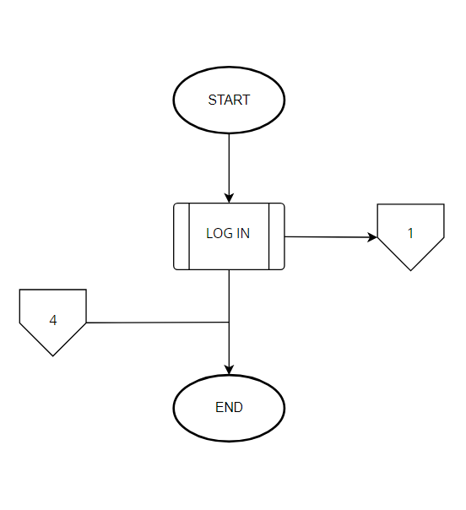

**Figure 3.** **Landing Page Flowchart**

**Figure 3. Landing Page Flowchart.** This flowchart shows what the users will be able to see first when accessing the system.

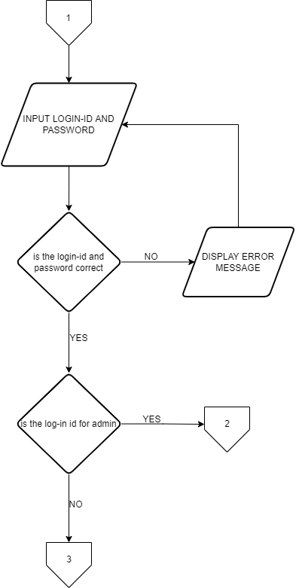

**Figure 4.** **Log In Flowchart**

**Figure 4. Log in Flowchart.** Log in page is the first page that will appear and will require a user to fill up with the registered user ID and its password. This flowchart exhibits the user levels the system has. It also contains the process when a user tries to log in on the system.

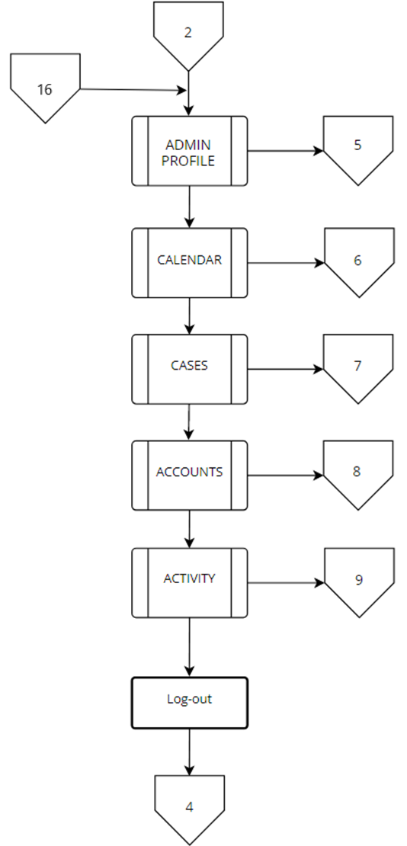

**Figure 5.** **Admin Landing Page Flowchart**

**Figure 5. Admin Landing Page.** This flowchart shows the admin panel processes such as the dashboard, calendar, manage cases, manage accounts and also the admin account settings.

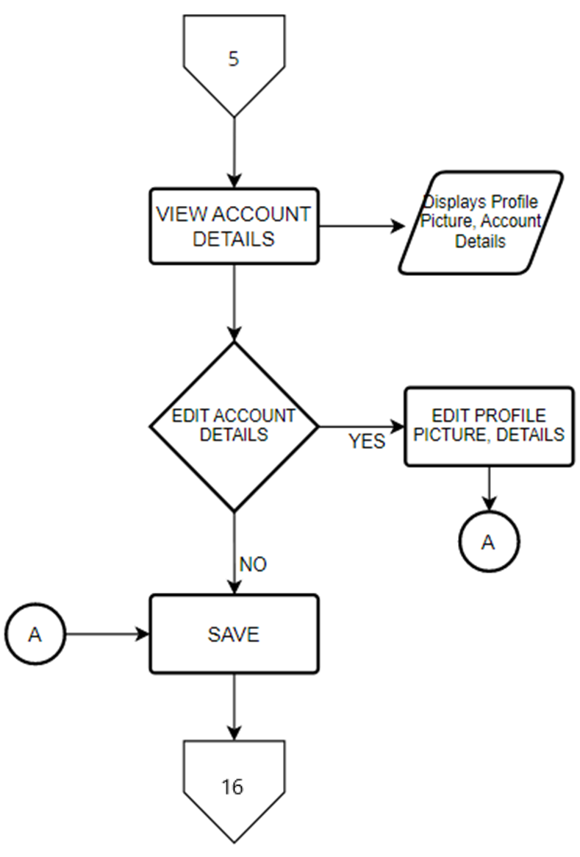

**Figure 6. Admin Account Details**

**Figure 6. Admin Account Details.** This flowchart shows the account detail page that displays the personal details and profile picture of the admin that can also be edited.

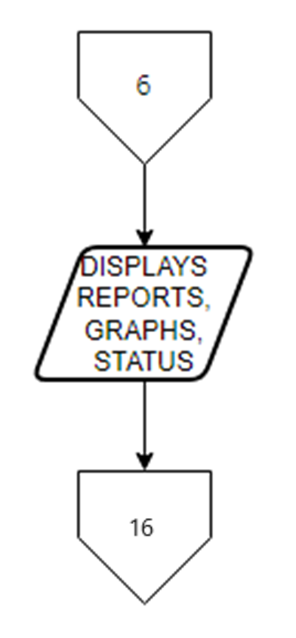

**Figure 7.** **Admin Dashboard Flowchart**

**Figure 7. Admin Dashboard Page.** This flowchart shows the admin dashboard page that displays the data analytics inside the system.

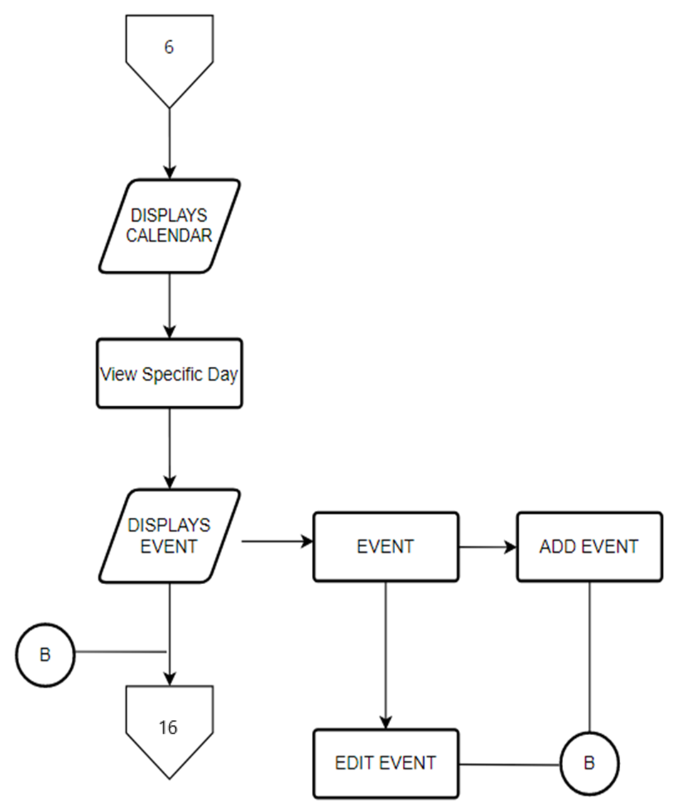

7

**Figure 8.** **Admin Calendar Flowchart**

**Figure 8. Admin Calendar Flowchart**. This flowchart displays the calendar wherein it has the schedule of case hearings and will also provide a real-time status.

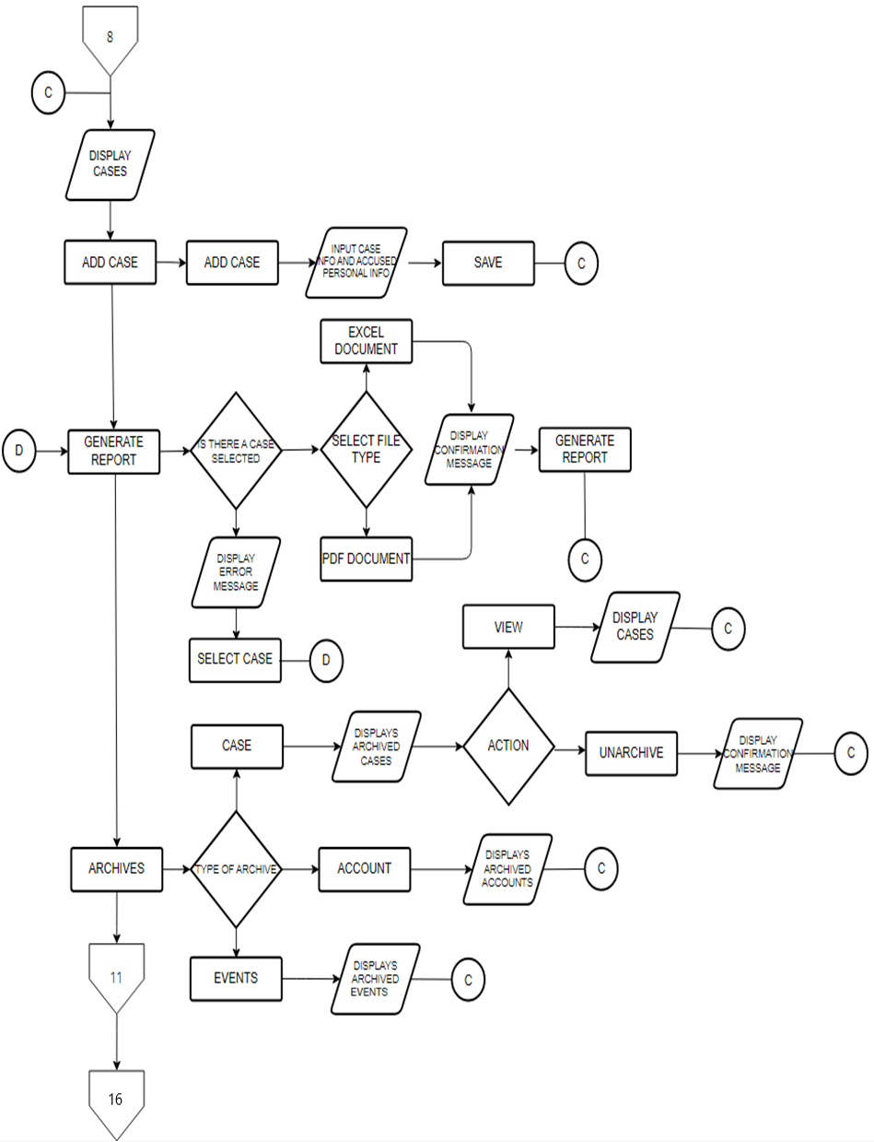

**Figure 9.1.** **Admin Cases Flowchart**

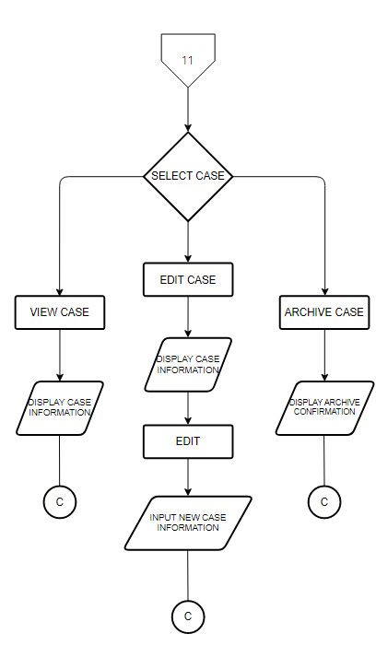

**Figure 9.2. Admin Cases Flowchart**

**Figure 9.1 & 9.2. Admin Cases Flowchart.** This flowchart shows the Cases tab that lets the admin to add, view, update, archive cases and also generates a PDF or EXCEL report.

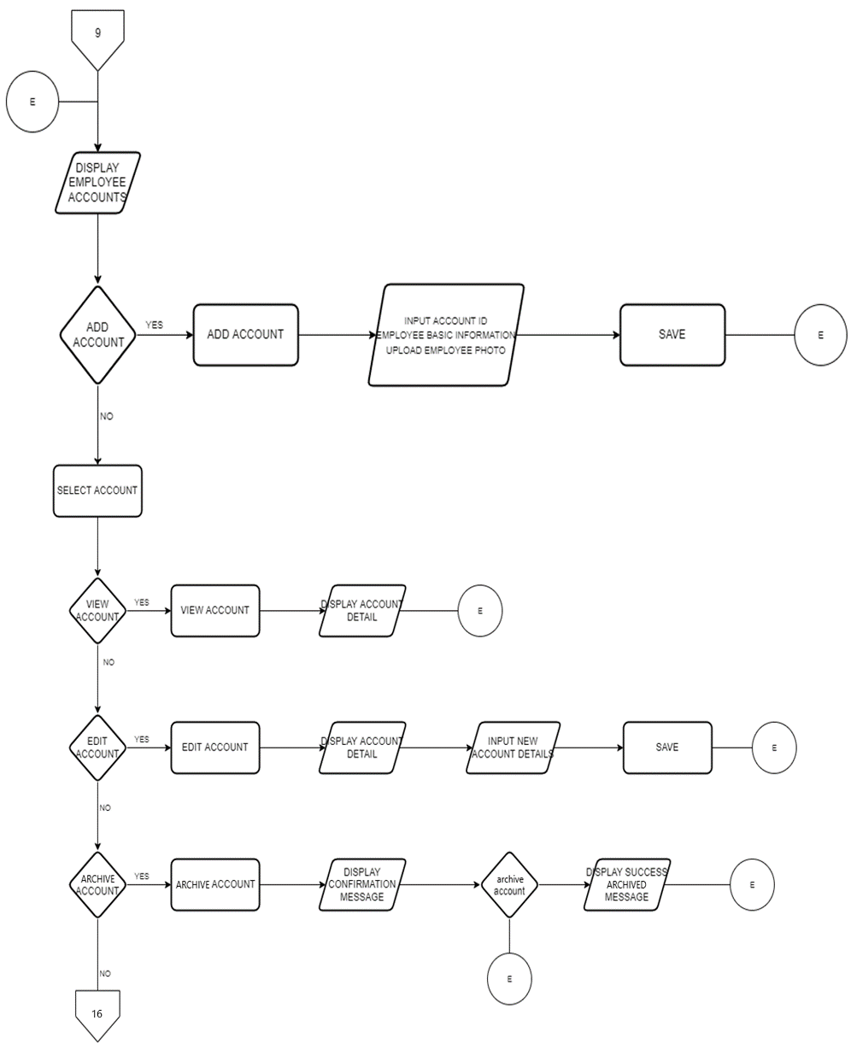

**Figure 10.** **Admin Accounts Page Flowchart**

**Figure 10. Admin Accounts Page Flowchart.** This page shows employees account information and lets you to manage the accounts that can access the system.

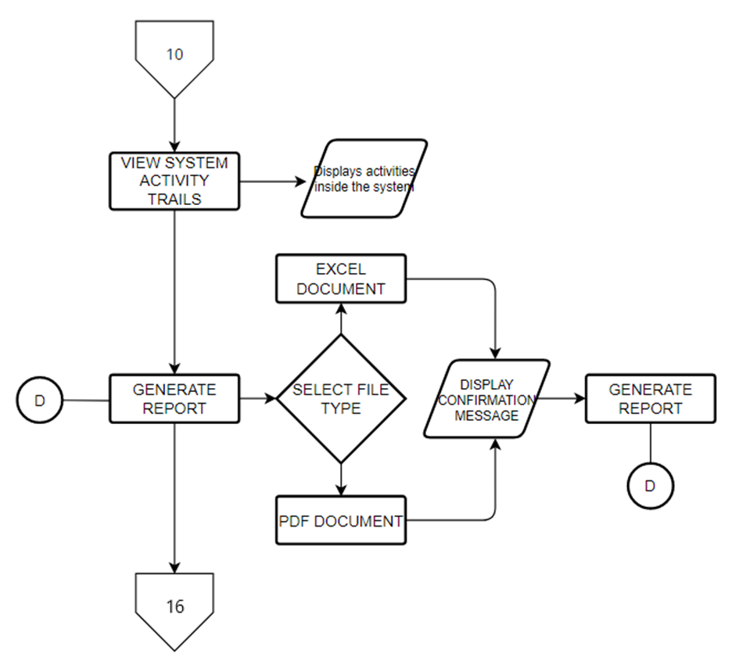

**Figure 11. Activity Page Flowchart**

**Figure 11. Activity Page Flowchart.** This page displays the movements and activities made inside the system.

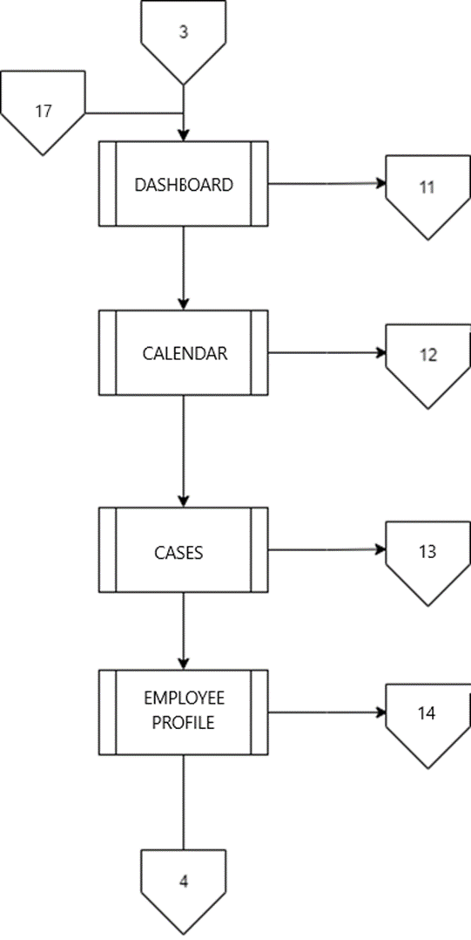

**Figure 12.** **Employee Landing Page Flowchart**

**Figure 12. Employee Landing Page Flowchart.** This page shows what an employee lever of user can do inside the system.

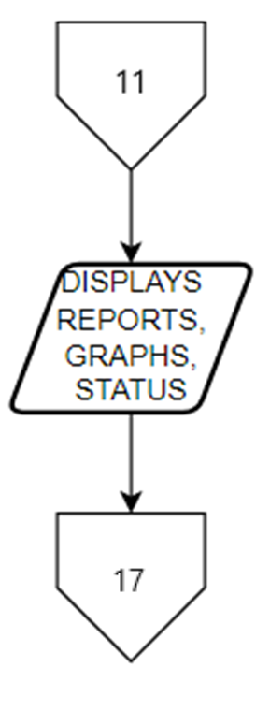

**Figure 13. Employee Dashboard Flowchart**

**Figure 13. Employee Dashboard Flowchart.** This flowchart shows the employee dashboard page that displays the data analytics inside the system.

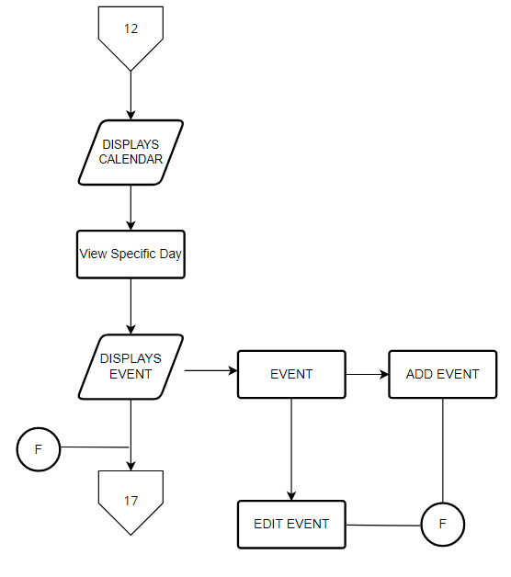

**Figure 14. Employee Calendar Flowchart**

**Figure 14. Employee Calendar Flowchart.** This flowchart displays the calendar wherein it has the schedule of case hearings and will also provide a real-time status.

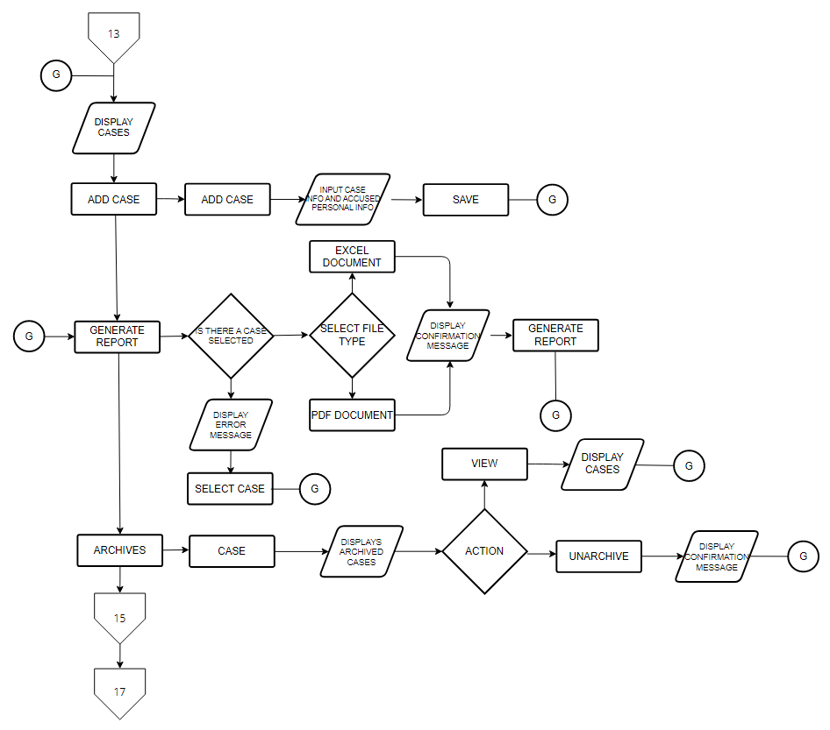**Figure 15.1.** **Employee Cases Flowchart**

**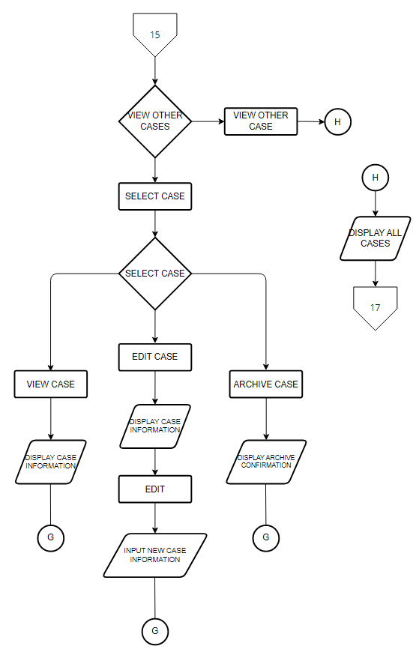  
Figure 15.2. Employee Cases Flowchart**

**Figure 15.2. Employee Cases Flowchart** This flowchart shows what a user with an employee level can do inside the system. As an employee, they can manage their own cases and view other cases as well as managing their own account.

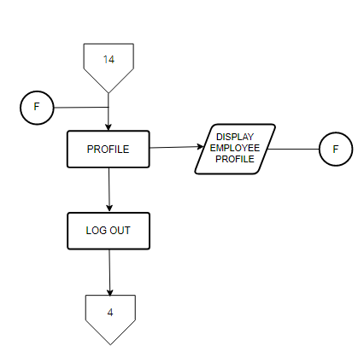

**Figure 16.** **Employee Profile Flowchart**

**Figure 16. Employee Profile Flowchart.** This flowchart shows the employee’s details.

**ENTITY RELATIONSHIP DIAGRAM**

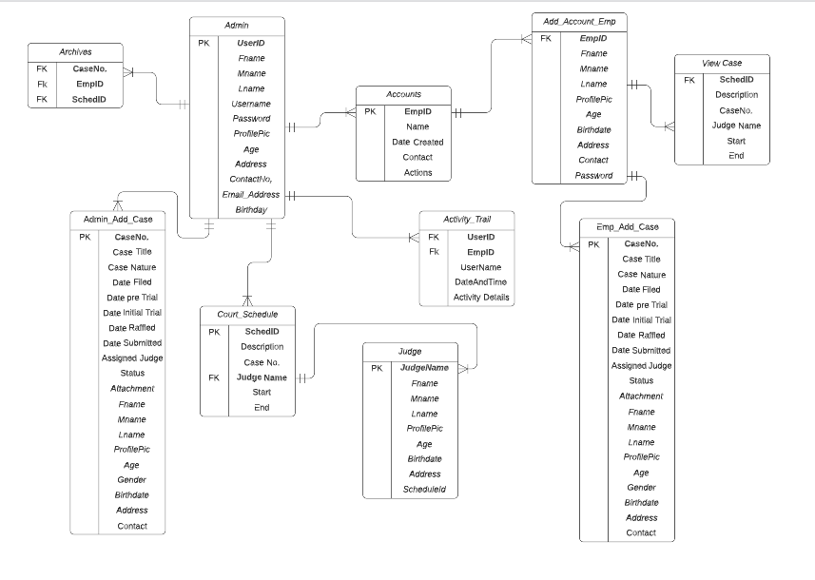

**Figure 17.** **Entity Relationship Diagram**

**Figure 17. Entity Relationship Diagram.** This diagram illustrates the relationships between entity sets inside this database.

**Development and Testing**

**ISO/IEC 25010: SOFTWARE QUALITY EVALUTION SYSTEM**

A product quality evaluation system's cornerstone is the quality model. When analyzing the properties of a software product, the quality model decides which quality characteristics will be considered.

A system's quality is determined by how well it meets the stated and implied needs of its many stakeholders and consequently adds value. The quality model, which divides product quality into characteristics and sub-characteristics, reflects the needs of those stakeholders (functionality, performance, security, maintainability, and so on).

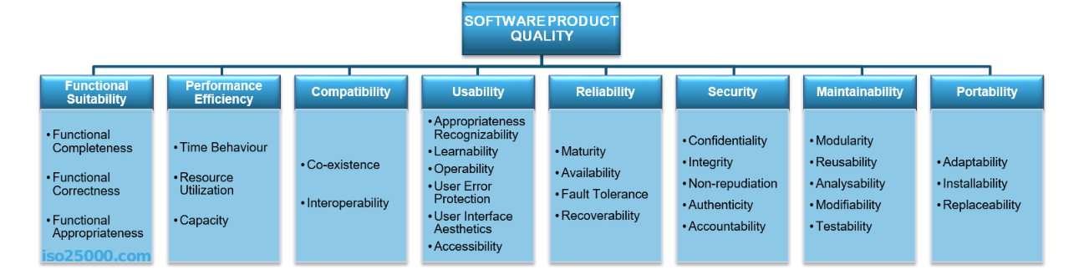 The eight quality characteristics displayed in the accompanying figure make up the ISO/IEC 25010 product quality model:

**Figure 18.** **SOFTWARE QUALITY EVALUATION**

The system had a different criteria’s including Functional Suitability, Performance Efficiency, Compatibility, Usability, Reliability, Security, Maintainability, and Portability.

**Table 4.**

**Respondents of Evaluation**

|  |  |  |
| --- | --- | --- |
| RESPONDENTS | FREQUENCY | PERCENTAGE |
| MALOLOS TRIAL COURT (EMPLOYEE) | 15 | 60% |
| IT EXPERTS | 10 | 40% |
| TOTAL: | 25 | 100% |

Table 4 presents the three respondents of the evaluation consisting of Malolos Trial Court (Employee) and IT (Information Technology) Experts, which are the respondents from different place in Malolos. Participants engaged in the system, shown in Figure 18 Respondents of Evaluation, it includes the testing and system evaluation.

The respondents of the study will include Malolos Trial Court (Employee), and End User members of respondents who lived in Malolos and last the IT Experts. The participants were selected because they were considered to be the most suitable for the study. An example of that is the Malolos Trial Court (Employee) who are familiar on managing the data of each case proceedings and all the information received the information gathered from respondents will be used strictly for data tabulation, interpretation, and analysis. No data from the study was used because the researchers strictly followed ethical guidelines.

**Table 5.**

**Five Point Likert Type Attitude Scale**

|  |  |  |
| --- | --- | --- |
| SCALE | RANGE | DESCRIPTIVE RATING |
| 1 | **1.00-1.49** | **Poor** |
| 2 | **1.50-2.49** | **Fair** |
| 3 | **2.50-3.49** | **Good** |
| 4 | **3.50-4.49** | **Very Good** |
| 5 | **4.50-5.00** | **Excellent** |

A Likert scale (typically) offers five options for answering a statement or question, allowing respondents to rate their level of agreement or emotion toward the statement or topic on a scale from positive to negative. According to a Likert scale, attitudes can be measured and their strength or intensity is linear, that is, on a scale from strongly agree to strongly disagree. Each of the five responses, for example, would be assigned a numerical value that would be used to assess the attitude under examination. Descriptive rating of 5 = “Excellent”, 4 = “Very Good”, 3 = “Good”, 2= “Fair,” and 1= “Poor.” The mean formula was used to get the respondents' ratings in various criteria.

**Where:**

M – Mean

Σ - Sum of all ratings

N – Number of respondents

**Formula:**

M=5(r)+4(r)+3(r)+2(r)+1(r)

N

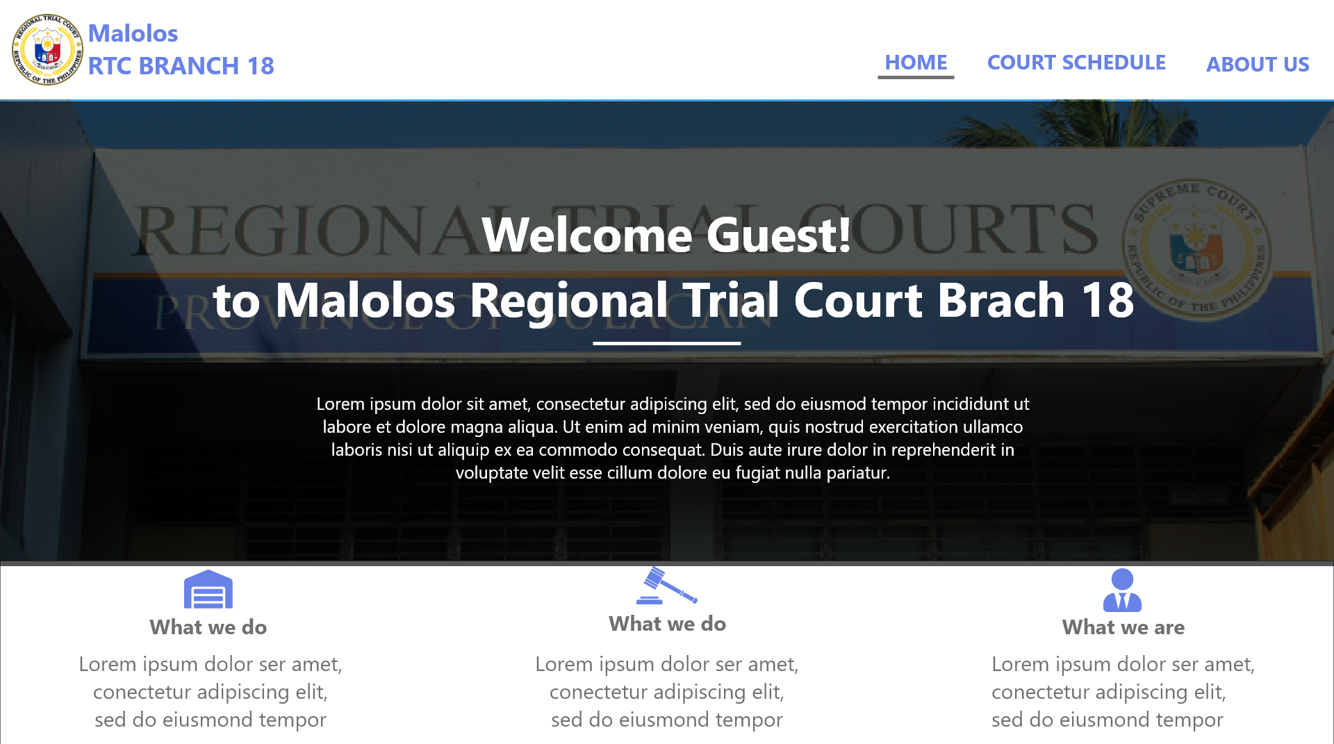 **Description of the Prototype**

**Figure 19.** **Guest Home Page**

The figure above displays the home page. This will provide a short description about the Malolos regional trial court.

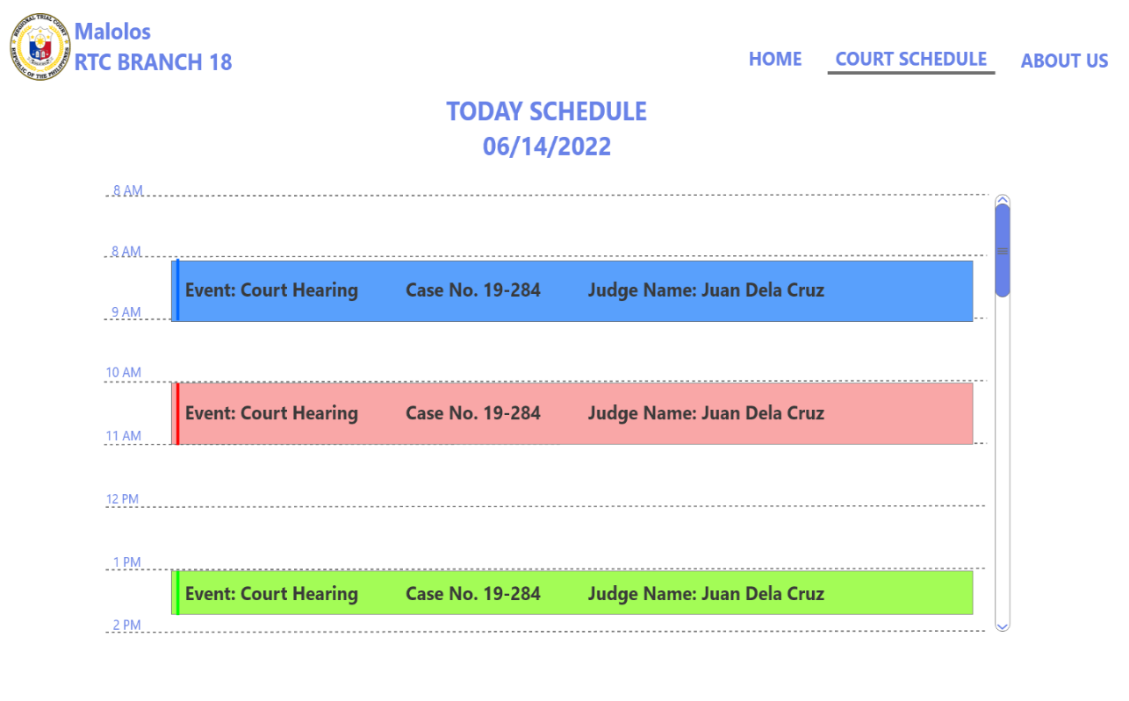**Figure 20.** **Guest Court Schedule**

The figure above displays the schedule of regional trial court. It only shows few information of cases for confidentiality.

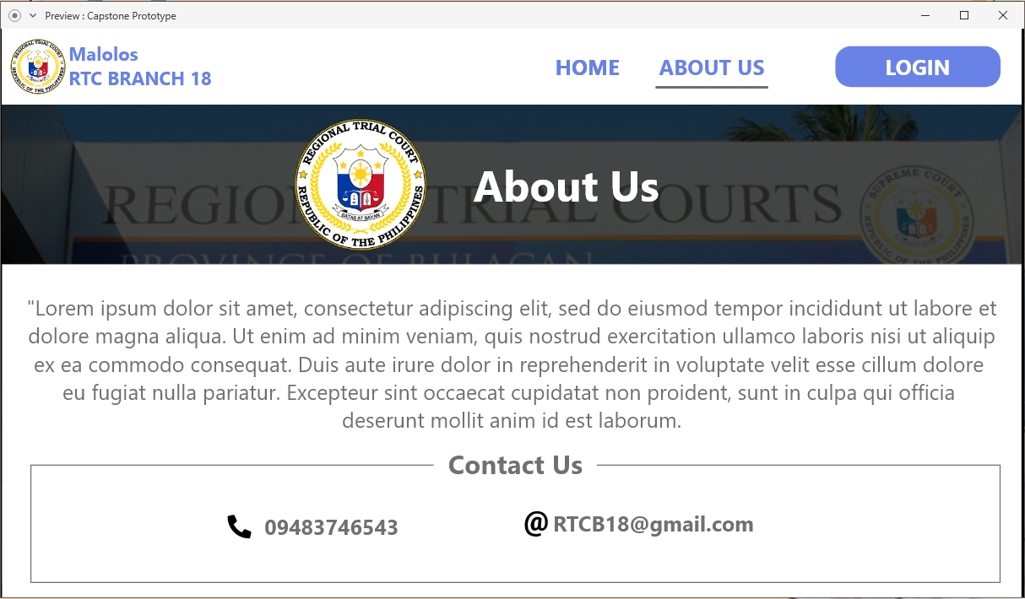**Figure 21.** **About Us Page**

The figure above shows the about us page which the user can see the brief description about the Malolos regional trial court. The contacts are also displayed here.

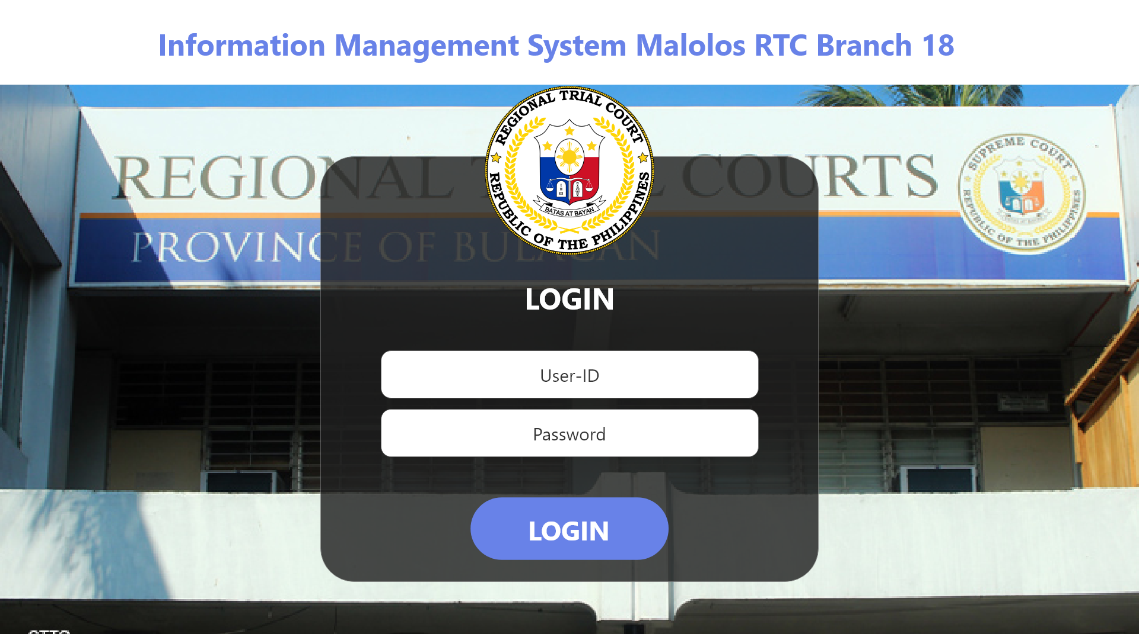**Figure 22.** **Login Page**

The figure above displays the login page. This page will give the user a choice to login as employee or as an administrator. Administrators are authorized to access all of the functionalities of the system while the employees are only allowed to handle their own cases.

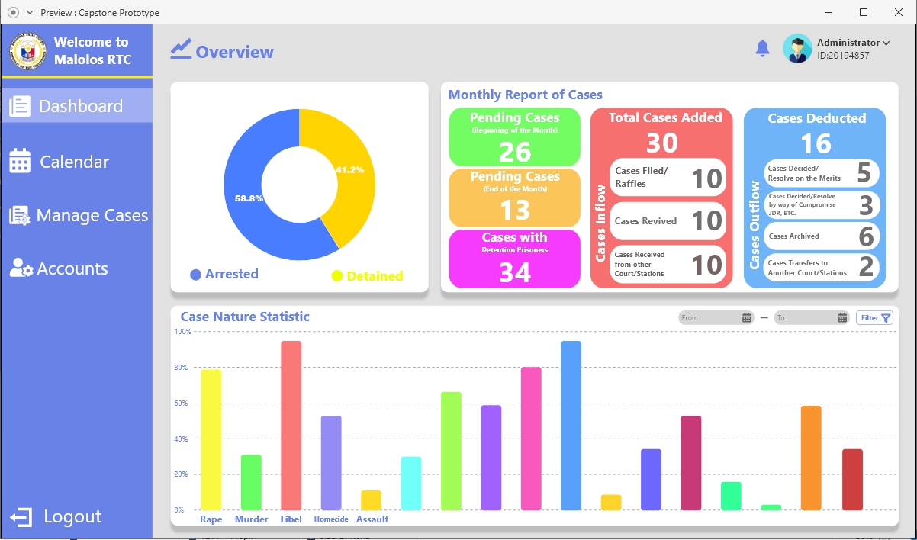**Figure 23.** **Admin Dashboard**

Figure 23 displays the admin dashboard; it provides quick access to important information and all of the functionalities on the system. The dashboard left tab holds all of the tools such as calendar, case management, and account management, while the rights side shows the activities and functions of every tool.

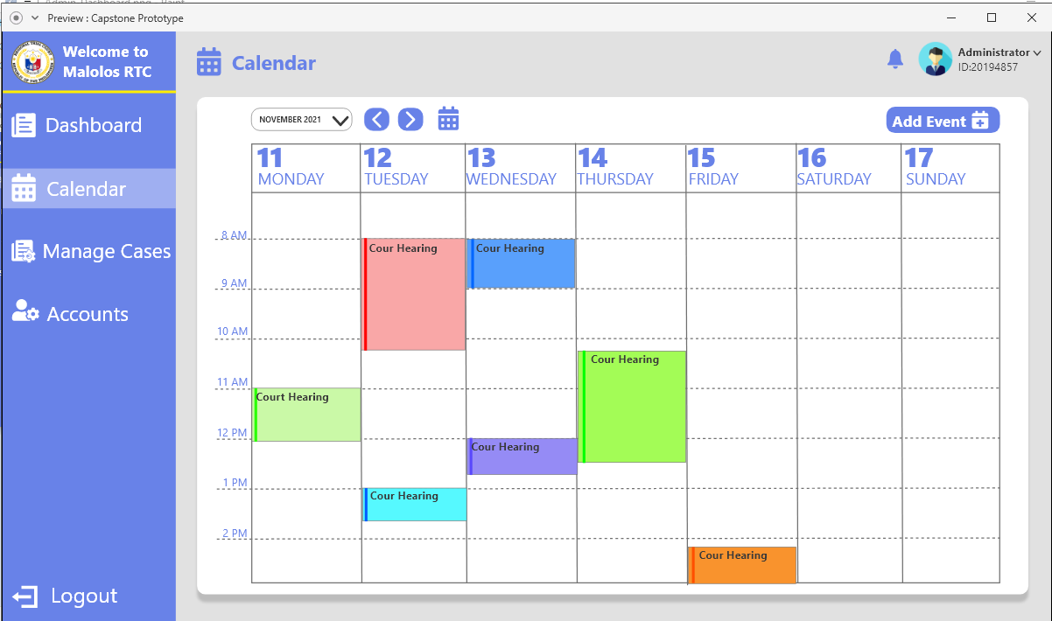**Figure 24.** **Admin Calendar**

Figure 24 shows court schedule, it will allow administrator to set a detailed schedule of future hearings and activities of the court. It will also provide a feature of real-time status for the current hearing and once the user clicks a specific event it will provide all of the information about it.

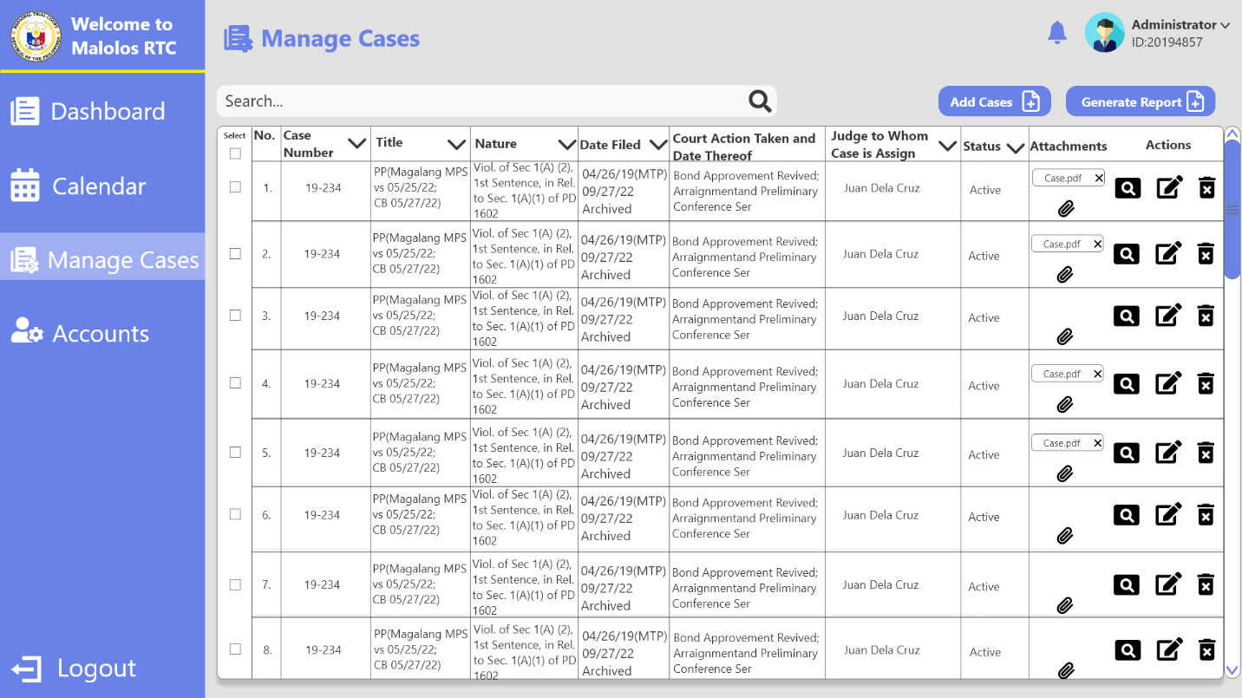**Figure 25.** **Admin Case Management**

The figure above shows the table of reported cases on the system this will allow the administrator to add, edit, view or archive a case, it also has a search bar and filter to easily track and manage a case.

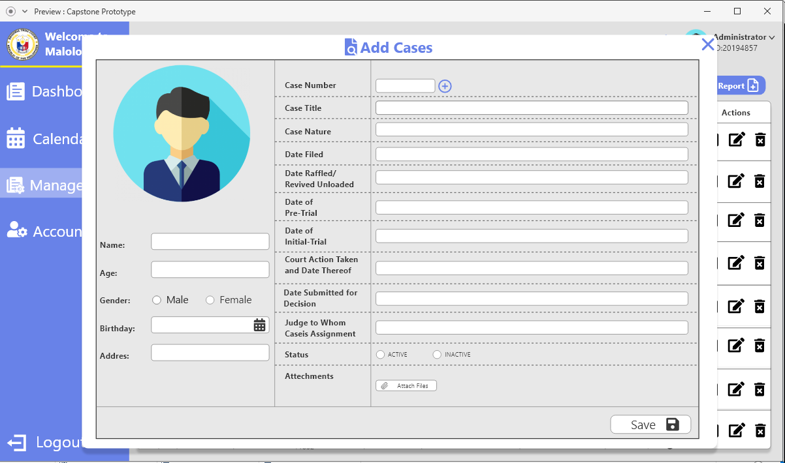**Figure 26.** **Add Case Form**

The figure above shows the new case form, where the user needs to fill up the following information about the case.

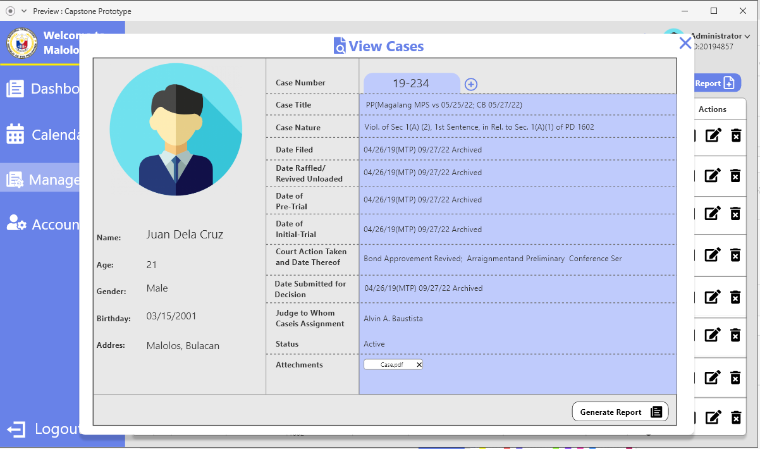**Figure 27.** **View Case Form**

The figure above shows the complete details of a case, the user can also generate a report of this case if needed.

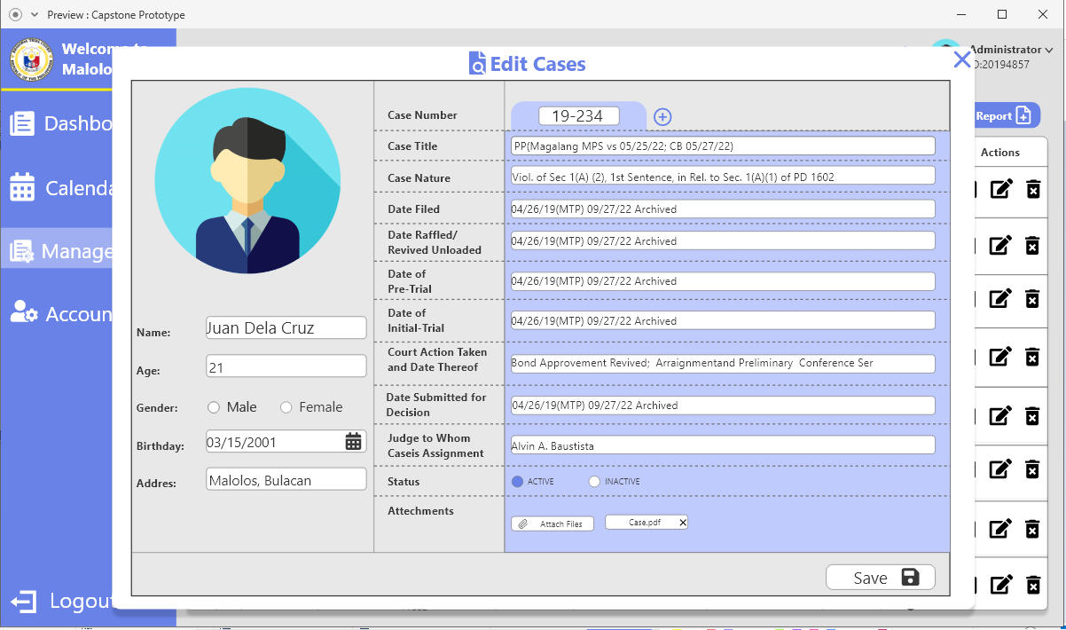**Figure 28.** **Edit Case Form**

The figure above shows the edit case where the user can edit all of the information of a certain case.

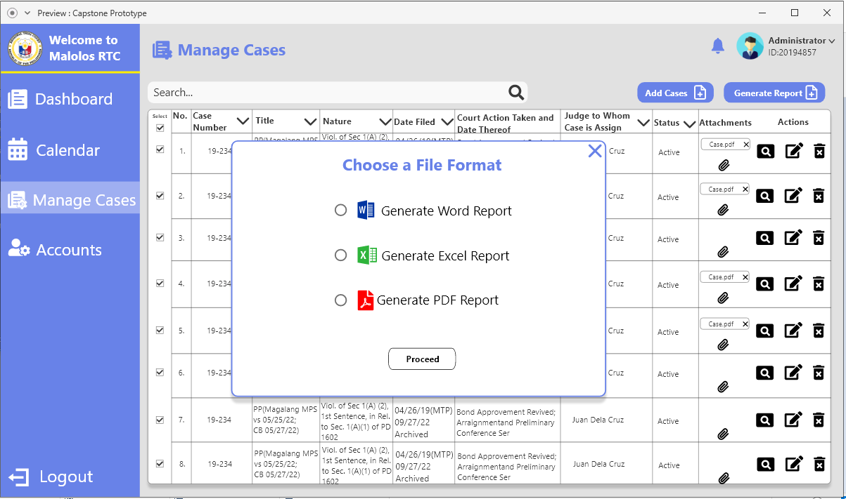**Figure 29.** **Report File Format**

The figure above shows a modal that list the available format when generating a report, these are word document, excel spreadsheet, and a pdf.

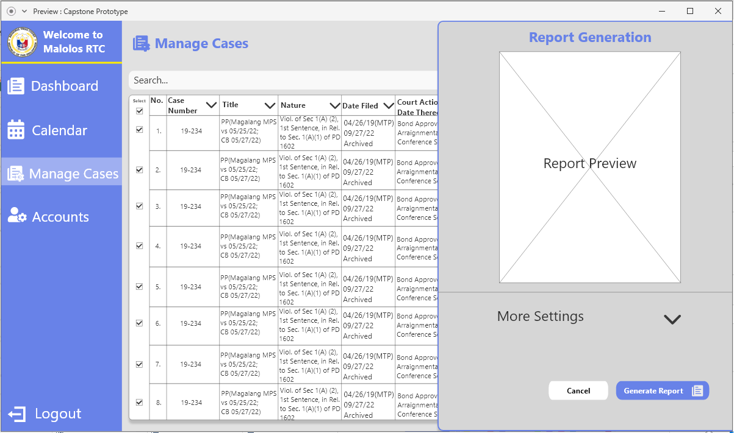**Figure 30.** **Report Generation**

The figure above displays the report generation which will show the preview of generated report, there are also a setting to create the report according to user preference.

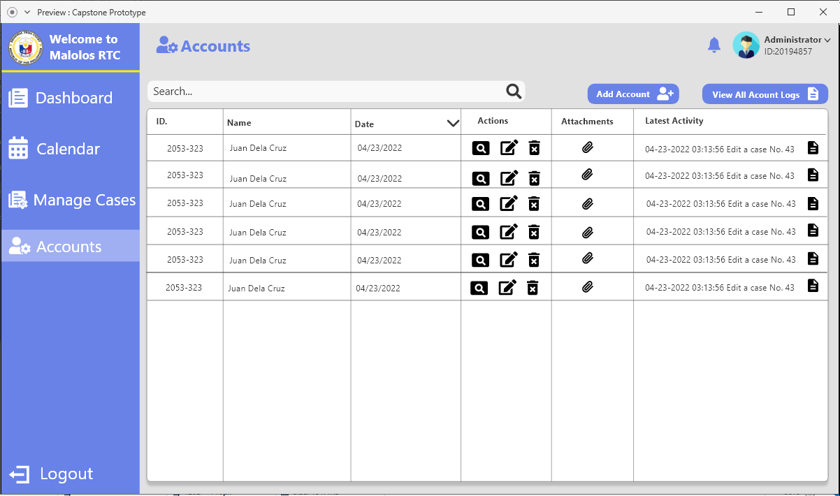**Figure 31.** **Account Page**

The figure above shows the list of the accounts. The administrator can add, view, edit, and archive any account. This page also shows the latest activity of any account.

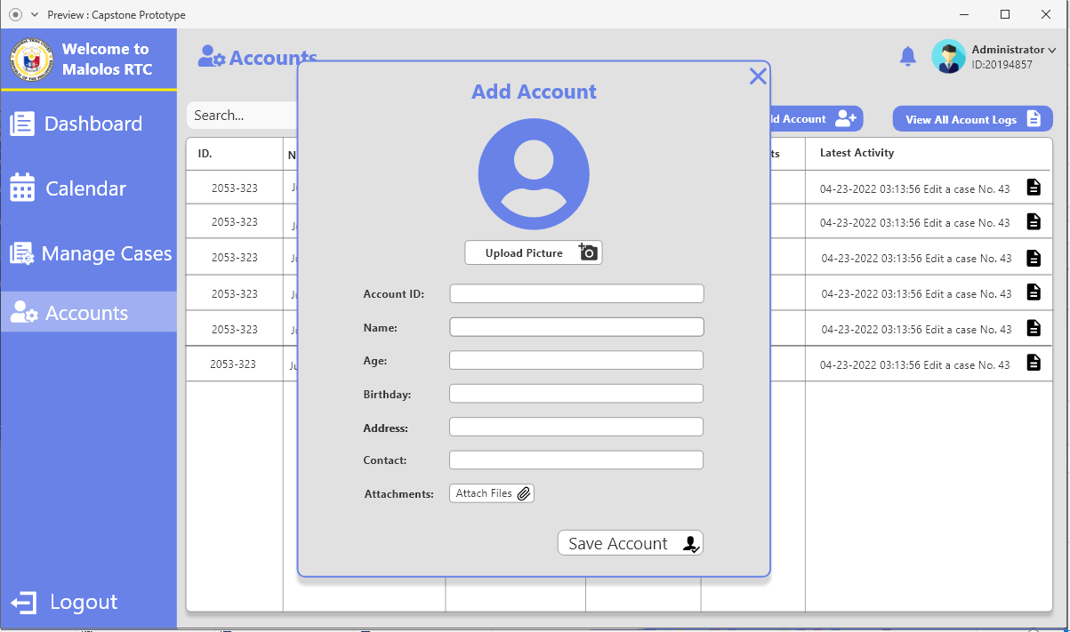**Figure 32.** **Add Account Form**

The figure above shows a form where the administrator can add accounts for the employees. Provide the necessary details to create an account.

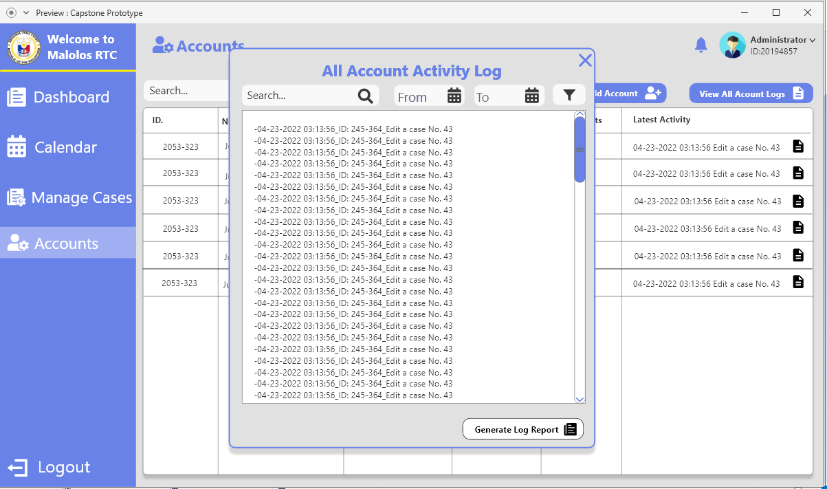**Figure 33.** **Accounts Activity Logs**

The figure above shows the complete logs of every account activity this is used to ensure the security of every information in the system, it can be also generated for report.

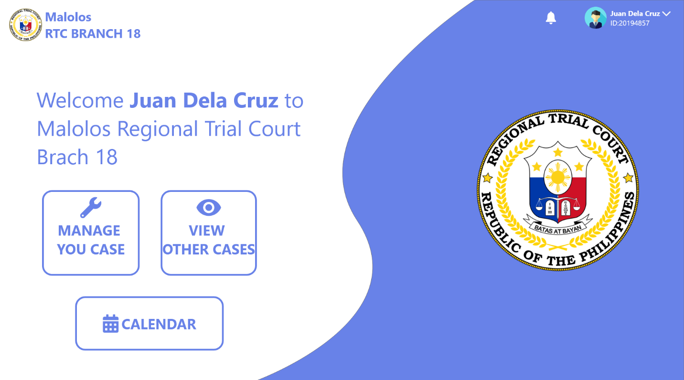**Figure 34.** **Employee Home Page**

The figure above shows all the functionalities available for employees, they are only allowed to manage their own cases, view other cases, and view the court schedule on calendar.

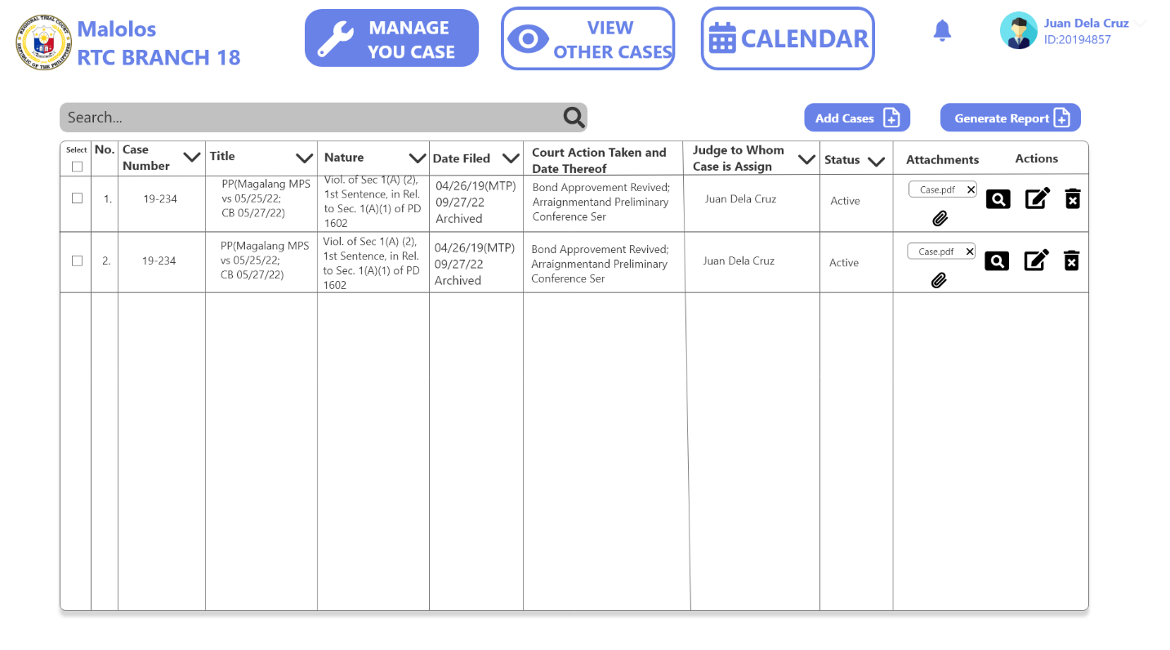**Figure 35.** **Employees Case Management**

The figure above shows the cases that an employee added. The user is only authorized to view, edit, and archive their own cases.

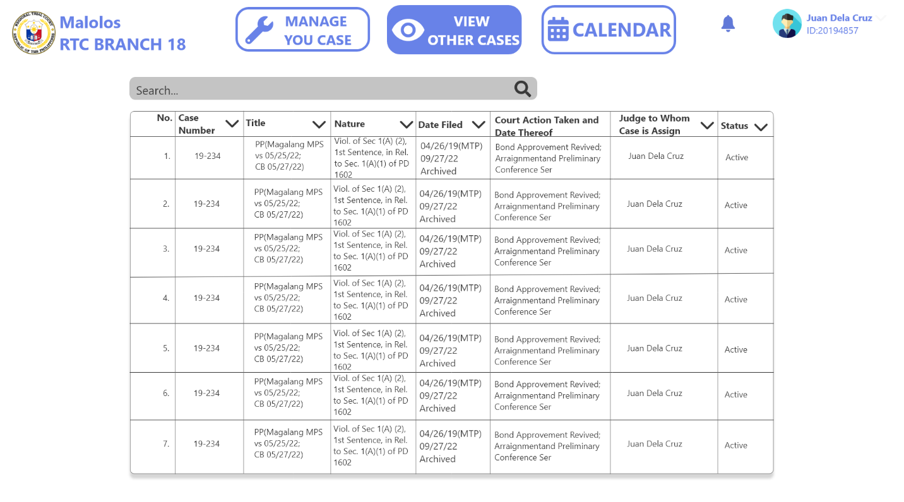**Figure 36.** **Employees View Case Page**

The figure above shows the list of all the cases created on the system; user employees are only authorized to view it.

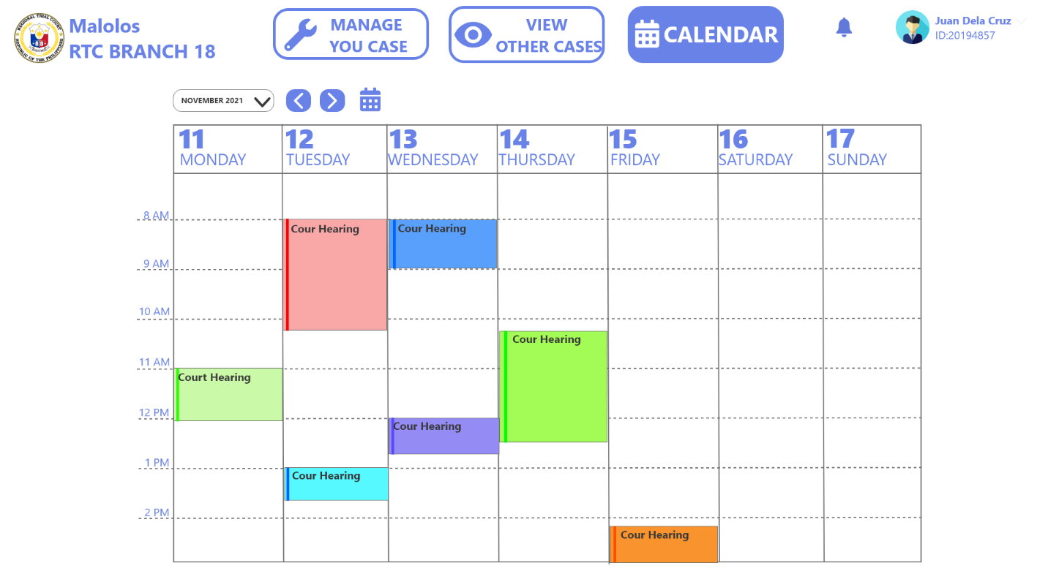**Figure 37.** **Employees Calendar**

The figure above shows the schedule of the court every event is provided with complete details created by the administrator.

**CHAPTER IV**

**RESULTS AND DISCUSSION**

This page showcases various tables and figures that visually represent the specifications of the system and the user’ level of satisfactory. This chapter also contains interpretations of the study’ results with accordance to the paper’ objectives to give the readers a concrete idea of the study’ attained goals.

**1. To Design a Management Information System with the following features.**

For the developers to produce a system that gives practical benefits to the users, the system must have features that collectively produce a product that contribute to the improvement of the user’ day-to-day work experience.

* 1. **Secure storage of Information**

Assurance of the data security plays a vital role in the success of a system and taking good care of information build confidence on the users and the institution. Figure 38 shows the log-in side of the system. Implementation of standards-adhering log-in feature enabled the system to ensure that the data within the system are protected from unauthorized people.

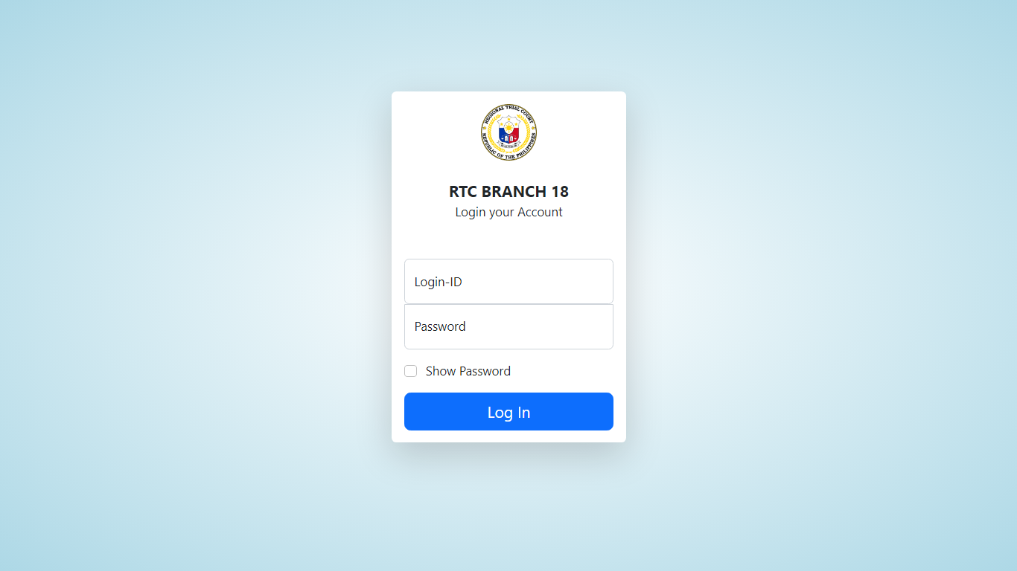

**Figure 38.** **System’s Log-In Page**

**1.2. Record Management**

The most important aspect of this system is to give modern and alternative way of creating and handling of information within the organization so the developers designed an effective way to create, view, modify and remove data. Figure 39 shows the system’ UI that helps to give a sense of ease and intuitiveness. With the help of this core feature, end users can expect a faster and efficient day-to-day workflow.

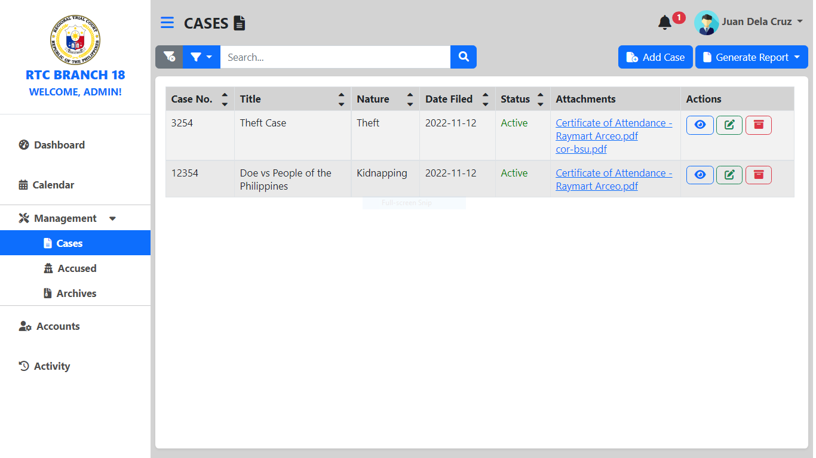

**Figure 39.** **Case Management Tab**

**1.3. Report Generation**

Another basic yet essential feature of the system is the ability to generate a digital or physical reports within the system, Figure 40 shows the system’ capability to generate these needed documents, these reports can be in .xsl or .pdf format giving users an option on how they want the report to look like. These reports will give a clear and detailed representation of data handled by the system.

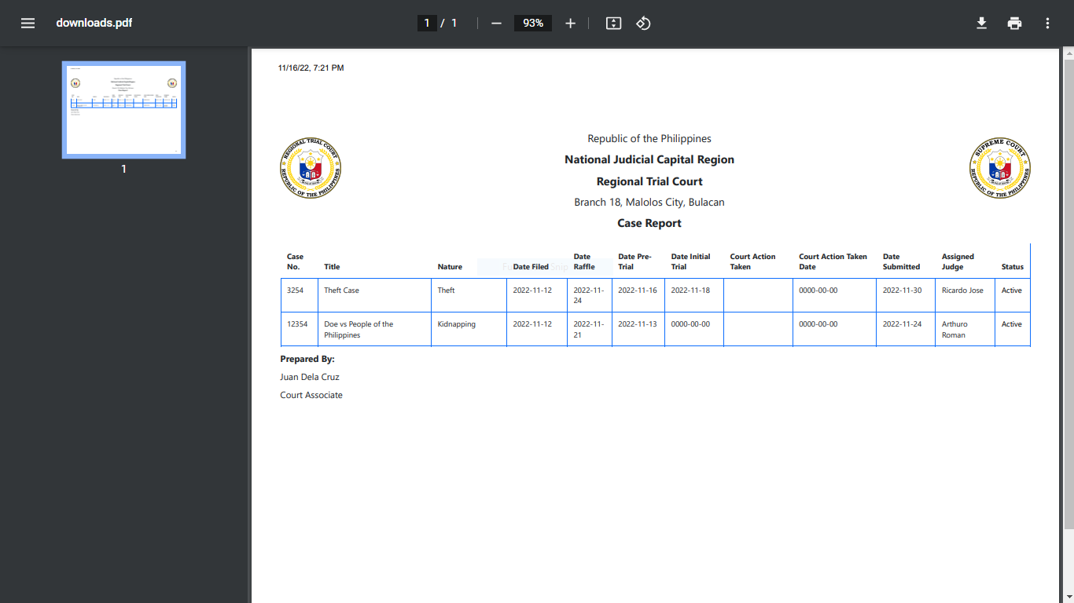

**Figure 40.** **System’s Report Generation Feature**

**1.4. Calendar**

Figure 41 showcases the system’s simple-looking yet effective calendar for the purpose of schedule tracking within the organization. This calendar allows users to add events that can be visible to every user, events can also be edited and remove from the system’ calendar.

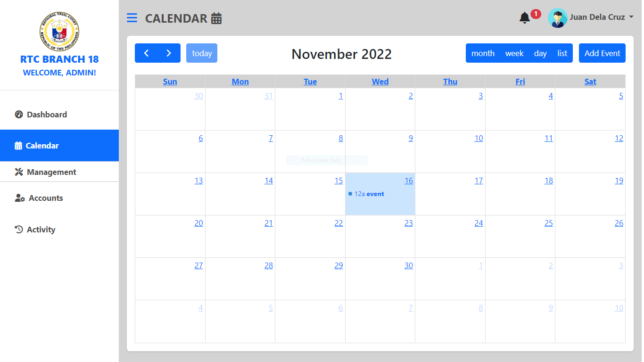

**Figure 41.** **System’s Calendar**

**2. To determine the acceptability of the system using the ISO/IEC 25010:2011 software quality evaluation criteria as perceived by the respondents on the following:**

To successfully develop a system that can bring useful benefits to as many people as possible and for it to be considered practically worth it, having the system adhere to industry’ standards is essential. With these factors considered, the users of the system are assured of efficient and high-quality system.

**2.1. Functional Suitability**

Table 6 presents Frequency Distribution and Descriptive Measures of the Respondents’ Ratings to the system in Terms of Functional Suitability. With the help of this table and its numbers, the developers were able to get a grasp of the respondent’ perspective which can then be used for future improvements.

**Table 6**

**Frequency Distribution and Descriptive Measures of the Respondents’ Ratings to the system in Terms of Functional Suitability**

|  |  |  |  |  |  |  |  |
| --- | --- | --- | --- | --- | --- | --- | --- |
| **Item** | **Frequency** | | | | | **Mean** | **Descriptive Interpretation** |
| **5** | **4** | **3** | **2** | **1** |
| **Functional Suitability** |  |  |  |  |  |  |  |
| **Functional Completeness.** Degree to which functions covers users’ objectives. | 12 | 11 | 2 | 0 | 0 | 4.4 | Very Good |
| **Functional Correctness.** Degree to which the system provides precise results | 9 | 10 | 6 | 0 | 0 | 4.12 | Very Good |
| **Functional Appropriateness.** Degree to which the system function accordingly. | 10 | 10 | 5 | 0 | 0 | 4.2 | Very Good |
| **Total Mean** |  |  |  |  |  | **4.24** | **Very Good** |

The table above shows a total mean of 4.24 as the ratings of the respondents towards the system’ Functional Suitability in the scale of 1 to 5 with Functional Completeness being the sub-category with the highest rating of 4.4 which signify that the system is successful in performing every task and all of the aspects related to it.

**2.2. Performance Efficiency**

Table 7 presents Frequency Distribution and Descriptive Measures of the Respondents’ Ratings to the system in Terms of Performance Efficiency. Interpretation of this table and its corresponding data helped the developers to get a grasp of the respondent’ perspective which can then be used for future improvements.

**Table 7**

**Frequency Distribution and Descriptive Measures of the Respondents’ Ratings to the system in Terms of Performance Efficiency**

|  |  |  |  |  |  |  |  |
| --- | --- | --- | --- | --- | --- | --- | --- |
| **Item** | **Frequency** | | | | | **Mean** | **Descriptive Interpretation** |
| **5** | **4** | **3** | **2** | **1** |
| **Performance Efficiency** |  |  |  |  |  |  |  |
| **Time Behavior.** Degree of the system’ processing time. | 13 | 7 | 4 | 1 | 0 | 4.28 | Very Good |
| **Resource Utilization.** Degree of system’ usage of resources while operating | 11 | 10 | 4 | 0 | 0 | 4.28 | Very Good |
| **Capacity.** System’ parameter limits meet the requirements. | 7 | 16 | 2 | 0 | 0 | 4.2 | Very Good |
| **Total Mean** |  |  |  |  |  | **4.25** | **Very Good** |

The table above shows the ratings of the respondents towards the system’ Performance Efficiency which was rated 4.25 overall and with Time Behavior and Resource Utilization being the highest rated with 4.28 which suggest that the system is capable of performing in consideration with time efficiency and while also saving vital resources.

**2.3. Compatibility**

Table 8 presents Frequency Distribution and Descriptive Measures of the Respondents’ Ratings to the system in Terms of compatibility. Interpretation of this table and its corresponding data helped the developers to get a grasp of the respondent’ perspective which can then be used for future improvements.

**Table 8**

**Frequency Distribution and Descriptive Measures of the Respondents’ Ratings to the system in Terms of Compatibility**

|  |  |  |  |  |  |  |  |
| --- | --- | --- | --- | --- | --- | --- | --- |
| **Item** | **Frequency** | | | | | **Mean** | **Descriptive Interpretation** |
| **5** | **4** | **3** | **2** | **1** |
| **Compatibility** |  |  |  |  |  |  |  |
| **Co-existence.** System; performance while communicating with other system. | 8 | 12 | 5 | 0 | 0 | 4.12 | Very Good |
| **Interoperability.** Information sharing between two or more systems. | 7 | 13 | 5 | 0 | 0 | 4.08 | Very Good |
| **Total Mean** |  |  |  |  |  | **4.1** | **Very Good** |

The numbers presented above shows the perception of the respondents towards the system’ Compatibility aspect, the numbers generated by surveys resulted to a mean of 4.1 and with Co-existence rated the highest with 4.12 which signifies that the system meet the expectations of the users for the system to work even with the presence of other entity. The numbers gathered from the respondents were concisely interpreted to give a detailed representation of the results.

**2.4. Usability**

Table 9 presents Frequency Distribution and Descriptive Measures of the Respondents’ Ratings to the system in Terms of Usability. With the help of this table and its corresponding data helped the developers to understand the respondent’ perspective which can then be used for future improvements.

**Table 9**

**Frequency Distribution and Descriptive Measures of the Respondents’ Ratings to the system in Terms of Usability**

|  |  |  |  |  |  |  |  |
| --- | --- | --- | --- | --- | --- | --- | --- |
| **Item** | **Frequency** | | | | | **Mean** | **Descriptive Interpretation** |
| **5** | **4** | **3** | **2** | **1** |
| **Usability** |  |  |  |  |  |  |  |
| **Appropriateness recognizability.** System’ functions are appropriate for users’ needs. | 15 | 7 | 3 | 0 | 0 | 4.48 | Very Good |
| **Learnability.** Degree to which users can learn the system effectively. | 11 | 11 | 3 | 0 | 0 | 4.32 | Very Good |
| **Operability.** System is easy to operate | 11 | 10 | 3 | 1 | 0 | 4.24 | Very Good |
| **User error protection.** Degree to which a system protects users against making errors. | 11 | 10 | 4 | 0 | 0 | 4.28 | Very Good |
| **User interface aesthetics.** Degree to which a user interface enables pleasing and satisfying interaction for the user. | 10 | 12 | 2 | 1 | 0 | 4.24 | Very Good |
| **Accessibility.** System is usable for people of different capabilities. | 9 | 14 | 2 | 0 | 0 | 4.28 | Very Good |
| **Total Mean** |  |  |  |  |  | **4.31** | **Very Good** |

The numbers presented in the previous table shows a mean of 4.31 as a numeric translation of the perception of the respondents towards the system’ Compatibility aspect, and the numbers also suggest that the system is able to recognize the user’s needs as evident from the rating of 4.48 rated for the system’s Appropriateness.

**2.5. Reliability**

Table 10 shows the Frequency Distribution and Descriptive Measures of the Respondents’ Ratings to the system in Terms of Reliability. With the responses gathered, developers will be able to assess the system’ reliability and theses assessments will be of good use for the future improvements of the system.

**Table 10**

**Frequency Distribution and Descriptive Measures of the Respondents’ Ratings to the system in Terms of Reliability**

|  |  |  |  |  |  |  |  |
| --- | --- | --- | --- | --- | --- | --- | --- |
| **Item** | **Frequency** | | | | | **Mean** | **Descriptive Interpretation** |
| **5** | **4** | **3** | **2** | **1** |
| **Reliability** |  |  |  |  |  |  |  |
| **Maturity.** Degree to which a system, product or component meets needs for reliability under normal operation. | 10 | 11 | 4 | 0 | 0 | 4.24 | Very Good |
| **Availability.** The system is accessible when required. | 13 | 9 | 3 | 0 | 0 | 4.4 | Very Good |
| **Fault Tolerance.** The system can perform despite some hardware faults. | 8 | 14 | 3 | 0 | 0 | 4.2 | Very Good |
| **Recoverability.** The system can recover information affected by some issues. | 11 | 13 | 1 | 0 | 0 | 4.4 | Very Good |
| **Total Mean** |  |  |  |  |  | **4.31** | **Very Good** |

The numbers presented above shows 4.31 as the numeric perception of the respondents towards the system’ Reliability aspect. With Availability and Recoverability being rated the highest with 4.4, the system was proven as capable to perform for the institution’ needs whenever it is needed and that the system is capable of performing even with the occurrence of some significant issues.

**2.6. Security**

Another vital aspect of the system is its capability to perform while being able to secure valuable information within the organization. Table 11 shows the Frequency Distribution and Descriptive Measures of the Respondents’ Ratings to the system in Terms of Security. With the responses gathered, developers will be able to analyze the system’ security and all this knowledge will be used to furtherly improve the system.

**Table 11**

**Frequency Distribution and Descriptive Measures of the Respondents’ Ratings to the system in Terms of Security**

|  |  |  |  |  |  |  |  |
| --- | --- | --- | --- | --- | --- | --- | --- |
| **Item** | **Frequency** | | | | | **Mean** | **Descriptive Interpretation** |
| **5** | **4** | **3** | **2** | **1** |
| **Security** |  |  |  |  |  |  |  |
| **Confidentiality.** Data within the system are available only to authorized people | 11 | 9 | 5 | 0 | 0 | 4.24 | Very Good |
| **Integrity.** Prevention of data modification by an unauthorized entity. | 12 | 8 | 5 | 0 | 0 | 4.28 | Very Good |
| **Non-repudiation.** Degree to which actions or events can be proven to have taken place so that the events or actions cannot be repudiated later. | 12 | 9 | 4 | 0 | 0 | 4.32 | Very Good |
| **Accountability.** Actions taken by an entity can only be traced from that entity. | 10 | 13 | 2 | 0 | 0 | 4.32 | Very Good |
| **Authenticity.** Degree to which the identity of a subject or resource can be proved to be the one claimed. | 14 | 7 | 3 | 1 | 0 | 4.36 | Very Good |
| **Total Mean** |  |  |  |  |  | **4.3** | **Very Good** |

The numbers presented above shows the results from the respondents when asked for their actual experience towards the system’ Security aspect, the responses gathered through surveys specifically 4.3 as the overall rating and 4.36 for the system’s Authenticity aspect, these numbers suggest that the system is generating real information extracted from authentic raw data.

**2.7. Maintainability**

Maintainability plays a vital role in the overall success of a system especially, it dictates its capability to adjust with different such as time, demand and technology advancement. Table 12 shows the Frequency Distribution and Descriptive Measures of the Respondents’ Ratings to the system in Terms of Maintainability. With the responses gathered, developers will be able to analyze the system’ capability to adjust for future needs and this will be used to furtherly improve the system.

**Table 12**

**Frequency Distribution and Descriptive Measures of the Respondents’ Ratings to the system in Terms of Maintainability**

|  |  |  |  |  |  |  |  |
| --- | --- | --- | --- | --- | --- | --- | --- |
| **Item** | **Frequency** | | | | | **Mean** | **Descriptive Interpretation** |
| **5** | **4** | **3** | **2** | **1** |
| **Maintainability** |  |  |  |  |  |  |  |
| **Modularity.** System is composed of discrete components. | 11 | 10 | 4 | 0 | 0 | 4.28 | Very Good |
| **Reusability.** Assets can be used in other system or to build other assets. | 11 | 12 | 2 | 0 | 0 | 4.36 | Very Good |
| **Analyzability.** The system can be diagnosed for deficiencies and issues. | 7 | 11 | 6 | 1 | 0 | 3.96 | Good |
| **Modifiability.** Degree to which a system can be effectively and efficiently modified without introducing defects. | 11 | 12 | 2 | 0 | 0 | 4.36 | Very Good |
| **Testability.** Degree of effectiveness and efficiency with which test criteria can be established for a system. | 10 | 12 | 3 | 0 | 0 | 4.28 | Very Good |
| **Total Mean** |  |  |  |  |  | **4.2** | **Very Good** |

With overall rating of 4.2 and 4.36 dedicated for system’s Reusability and Modifiability aspects, it was concluded that the development process resulted in a system that allows users or the institution to use generated data to create new information and a system that is capable of being modified in accordance to the needs of the organization.

**2.8. Portability**

Portability allows a system to be ported to another device which can be crucial in an organization, it dictates the system’ capability to work as it is intended despite the need of migration to another platform. Table 13 shows the Frequency Distribution and Descriptive Measures of the Respondents’ Ratings to the system in Terms of Portability. With the responses gathered, developers will be able to analyze the system’ capability to adjust for future needs and this will be used to furtherly improve the system.

**Table 13**

**Frequency Distribution and Descriptive Measures of the Respondents’ Ratings to the system in Terms of Portability**

|  |  |  |  |  |  |  |  |
| --- | --- | --- | --- | --- | --- | --- | --- |
| **Item** | **Frequency** | | | | | **Mean** | **Descriptive Interpretation** |
| **5** | **4** | **3** | **2** | **1** |
| **Portability** |  |  |  |  |  |  |  |
| **Adaptability.** The system can perform efficiently with new usage environments | 9 | 13 | 3 | 0 | 0 | 4.24 | Very Good |
| **Installability.** The system can be place or remove in a specific environment. | 11 | 13 | 1 | 0 | 0 | 4.4 | Very Good |
| **Replaceability.** The system can replace other product in a certain environment. | 14 | 8 | 3 | 0 | 0 | 4.44 | Very Good |
| **Total Mean** |  |  |  |  |  | **4.36** | **Very Good** |

The numbers presented in the recent seen table shows the results gathered from the respondents which are related to their actual experience towards the system’s Portability, the responses gathered through surveys which resulted to 4.36 as the overall mean and 4.44 rating for Replaceability, suggest that the system were able to meet the user’ expectations towards system’s capability to outperform other systems and testify to its potential to be a better solution to the current issues in the field.

**Chapter V**

**SUMMARY AND RECOMMENDATIONS**

This chapter showcases the summary of all the gathered results of the study. These findings are summarized and arranged in a manner that will allow the readers to easily understand and comprehend everything there is in this paper. With these results, the importance and potential benefits of this study will get unveiled.

**Summary of Findings**

This part of the paper features an overview of the gathered findings of this study that are specifically related to the system’s features and technical aspects. With the help of summarizing the results, the researchers were able to translate the study’s findings into a concise manner that would allow the readers to appreciate the study even more.

1. **To Design a Management Information System with the following features.**

During the interview and survey phases, the researchers discovered that the features included in the systems were working effectively and efficiently together and each feature plays a vital role for the success of the project. Participants of the surveys easily find the relevance and importance of all the system’ functionalities.

Introducing a new and secure way of managing information together with the ability to generate flexible report documents allow the users to accomplish tasks fast while still doing it correctly and with the addition of a calendar system helps in keeping things organized and added another level of convenience within the workplace.

1. **To evaluate the system through the following criteria.**

After analyzing the findings gathered from the evaluation phase, the researchers were able to conclude that the system is successful in complying to the standards. Referencing the data from the surveys, it was revealed that the system possesses technical characteristics that work collectively to make the system as good as it can get.

Adhering to software development standards and harnessing the system with vital technical characteristics contributed to the overall success of the project. With overall fair to good results of the evaluation towards the system’s prioritization of complying to the standards as stated in the ISO/IEC 25010:2011 criteria, enabled the researchers to develop a product that is not only contain needed features but also essential aspects that will give the users confidence in utilizing the system.

**Conclusions**

In relation to the stated findings, conclusions were drawn that will give concise remarks that compliments to the study’ objectives. These conclusions will additionally be essential for the readers to get a glance of the paper’ outcomes.

The developers were able to implement the core functionalities for the system with regards to the target users’ nature of work. With the functionalities of the system, users will benefit from the convenience and ease that the system offers which can eventually result to a better workflow inside the organization. Together with the core features that the users will experience once the system is implemented, the developers of the system were also able to give significant amount of consideration to the underlying criteria of the system such as its security, performance and other things that play a big role in the project’s successful implementation and utilization.

**Recommendations**

In line with the respondents’ feedbacks that were highlighted in the paper’ findings and conclusions, the following recommendation were drawn, this part of the paper will be beneficial for future researchers in the field of Information Technology who want to develop a similar study.

1. Implementing a file sharing feature within the system for the purpose of allowing third parties like different trial courts or individuals to send or related documents.
2. Development of a companion application that is specifically for mobile and that features some basic capabilities like viewing of event and dashboard contents will give flexibility to the users.
3. Implementing ability to link the system to a third-party system specifically those from the entities who raffle cases so that passing of cases from one trial court to another could be done instantly.

**Research Implications**

Implementation of this system will allow various group of individuals to gain valuable things that will enable them to gain essential things to be better at things that relates to their line of everyday routine.

Successful implementation of this project will allow the justice sector to realize a new and modern way of accomplishing related tasks, convenience that this system can bring inside a justice institution will contribute to a fast reliable service to the people and the community. Findings of this study and presence of this system will also give knowledge that can be a foundation for continuous development of better solutions to address current or future challenges in the justice sector.

**A. Books**

Jayoma, J., Moyon, E., & Morales, E.M. (2020). *OCR based document archiving and indexing using PyTesseract: A record management system for DSWD Caraga, Philippines* (1st ed.). Institute of Electrical and Electronics Engineers

Maisha, T., Abdullah, O., Shahriar, R., & Bhuiyan, Md. (2018). *CRAB: Blockchain based criminal record management system* (1st ed.). Springer, Cham.

Ungar M., (2021). Judicial System. *Democracy and Security in Latin America* (p. 14). Routledge. https://www.taylorfrancis.com/chapters/edit/10.4324/9780429291258-3/judicial-system-mark-ungar

**B. Book Chapter**

Tasnim, M.A., Omar, A.A., Rahman, M.S., Bhuiyan, M.Z.A. (2018). CRAB: Blockchain based criminal Record Management system. In: Wang, G., Chen, J., Yang, L. (eds), *Security, Privacy, and Anonymity in Computation, Communication, and Storage* (pp. 294-303). Springer, Cham.

**C. Journal Articles**

Burdon M., & Coles-Kemp L. (2019). The significance of securing as a critical component of information security: An Australian narrative, *Computers & Security*, 87, 108-121. https://doi.org/10.1016/j.cose.2019.101601.

Bondoc, B. C. . (2019). Towards Digitization through e-Barangay A Web-based Barangay Information System. International Journal of Humanities and Education Development (IJHED), 1(2), 88–91. https://theshillonga.com/index.php/jhed/article/view/318

Benzar G., (2020). Designing and implementing e-justice systems: An information systems approach to Regional Trial Court case docket management in northern Mindanao, Philippines, *International Journal of Multidisciplinary Academic Research,* *8(1),* 44-54, https:// doi.org/10.5281/zenodo.4459814

Gelashvili, T., and Pappel, I. (2021). Challenges of Transition to Paperless Management: Readiness of Incorporating AI in Decision-making Processes, *Eighth International Conference on eDemocracy & eGovernment (ICEDEG),* 41-46. 10.1109/ICEDEG52154.2021.9530905.

Grepon, B.G. (2020). Designing and implementing e-Justice systems: An information systems approach to regional trial court case docket management in Northern Mindanao, Philippines. *International Journal of Multidisciplinary Academic Research, 8*, 44-54. https://ssrn.com/abstract=4145061

Hughes, S. (2019). Scheduling using a Web-based calendar: How teamup enhances Communication, *Public Services Quarterly, 14*(6), 362-372. https://doi.org/10.1080/15228959.2018.1518184

Lestantri, I., & Rosini (2018). Evaluation of Software quality to improve Application performance using Mc call model, *Journal of Information Systems Engineering and Business Intelligence, 4*(1), 19-20.

Mohamed, F. E., & Bunawan, A. A. (2022). Effective records Management program inOrganization. *International Journal of Academic Research in Business and Social Sciences,* 12(4), 982–996. 10.6007/IJARBSS/v12-i4/12998

Mosweu, T.L. and Kenosi, L. (2018), Implementation of the Court Records Management System in the delivery of justice at the Gaborone Magisterial District, Botswana, *Records Management Journal,* *28*(3), 234-251. https://doi.org/10.1108/RMJ-11-2017-0033

Pereira T., Barreto L., & Amaral A. (2017) Network and information security challenges within Industry 4.0 paradigm, *Procedia Manufacturing*, *13*, 1253-1260. https://doi.org/10.1016/j.promfg.2017.09.047.

Ukaogba, J., & Nwankwo, I. (2020). Record Management practices of principals for effective administration of secondary schools in Delta state, *International Journal of Innovative Science and Research Technology, 5*(6), 501-503.

**D. Unpublished Thesis**

Orbeta Jr, A.C., Paqueo, V.B., & Siddiqi, B. (2021, February 1). *Impacts of electronic case management systems on court congestion in the Philippines.* International Initiative for Impact Evaluation. https://developmentevidence.3ieimpact.org/search-result- details/impact-evaluation-repository/impacts-of-electronic-case-management-systems-on-court-congestion-in-the-philippines/8946

**E. Electronic References**

American Bar Association. (2013, August). *Case Management System to Improve Efficiency in Philippine Trial Courts.* *https://www.americanbar.org/advocacy/rule_of_law/where_we_work/asia/philippines/ne ws/news_philippines_ecourt_0813/*

Agile methodology in software development [online image]. (2021). ResearchGate. https://www.researchgate.net/figure/Agile-Methodology-in-System-Development-source- Okeke2021-retrieved-from_fig1_354310848

Barrantes, E. (n.d). *The advantages of HTML reports.* IFRS Foundation. https://www.integratedreporting.org/news/the-advantages-of-html- reports/?fbclid=IwAR3uFL96386DNhzPemJ2rHZybeSLgR__9WDPGqv- gbG9GuKtaaT41_c32RY

Camacho P. (2020, February 19). Philippine Courts Go Paperless. *The Asia Foundation.*  https://asiafoundation.org/2020/02/19/philippine-courts-go-paperless/

Digite (n.d.). What is Agile methodology? – *Overview of Agile software development and Agile models.* https://www.digite.com/agile/agilemethodology/?fbclid=IwAR3BIg0Cufmso685VwbxDie25auAcf30b0JzeyKg19rX1Pktdvsc-gY6_U

Indeed. (2021, August 19). *What is data reporting? (Plus how to write a data report).*  https://www.indeed.com/career-advice/career-development/what-is-data-reporting

Lawphil (n.d.). Philippine Laws and Jurisprudence Databank. Arellano Law Foundation https://lawphil.net/

Ludlow, P. (2018, March 22). *Traditional records management isn’t working for government – or anybody else*. Opentext. https://blogs.opentext.com/traditional-records-management-isnt- working-government/

PACER, (n.d). Public Access to Court Electronic Records, *What is PACER?* https://pacer.uscourts.gov/

Singh, M., Sahu, Ganesh., Dwivedi, Y., Rana, N., and Tamilmani, K. (2018). Success Factors for e-Court Implementation at Allahabad High-Court, *PACIS 2018 Proceedings.* 137. https://aisel.aisnet.org/pacis2018/137

Sloan, K. (2018, February 2). *4 Benefits of Using a Scheduling System in Your Business.* Calendar.com. https://www.calendar.com/blog/scheduling-system-business/

Software Testing Fundamentals (n.d.). *Acceptance Testing.* https://softwaretestingfundamentals.com/acceptance-testing/

United Nations Archieves. (n.d). *Understanding Records Management. https://archives.un.org/content/understanding-records-management*

Voxco. (2021). *Descriptive Research: Definition, Methods & Examples.* https://www.voxco.com/blog/descriptive-research/

Wang, J., Zhang, H., Zhang, C., Yang, W., Shao, L., & Wang. J. (2019, September). *An Effective Scheme for Generating An overview report over a very large corpus of documents.* ACM Symposium on Document Engineering. https://dl.acm.org/doi/abs/10.1145/3342558.3345394

Wrike (n.d). *Why Should I Use Calendars in Project Management Software?* https://www.wrike.com/project-management-guide/faq/why-should-i-use-calendars-in-project-management-software/

**Appendix A**

*Communication Letters*

Republic of the Philippines

Bulacan State University

**Graduate School**

City of Malolos, Bulacan

November 22, 2022

**Mr. John Michael D. Calizon**

Faculty

College of Information and Communications Technology

Bulacan State University

Dear Sir:

Greetings!

I am Kayeleigh C. Luluquisin, team leader of Group 5 from BSIT 4I, a student of Bulacan State University taking up Bachelor of Science in Information Technology and currently working on my paper in thesis writing. We sincerely ask your assistance for the validation of our interview guide form in my thesis entitled: “Web-based Management Information System for Malolos Regional Trial Court Branch No. XVIII”.

In connection with this, I would like to ask your approval regarding the interview guide form attached. Its purpose is to determine the daily operations and its problems encountered of the Commission.

I am looking forward for your response about this matter. Thank you very much and God bless.

Sincerely yours,

**Luluquisin, Kayeleigh C. - Group 5 - Leader**

BSIT Student

**Approved Disapproved**

**Comments:_________________________________________________________________________________________________________________________________________________________________________________________________________________________________**

**Mr. John Michael D. Calizon**

Faculty

Republic of the Philippines

Bulacan State University

**Graduate School**

City of Malolos, Bulacan

November 22, 2022

**Engr. Lester Phil M. Cruz, MSCpE**

Faculty

College of Information and Communications Technology

Bulacan State University

Dear Sir:

Greetings!

I am Kayeleigh C. Luluquisin, team leader of Group 5 from BSIT 4I, a student of Bulacan State University taking up Bachelor of Science in Information Technology and currently working on my paper in thesis writing. We sincerely ask your assistance for the validation of our interview guide form in my thesis entitled: “Web-based Management Information System for Malolos Regional Trial Court Branch No. XVIII”.

In connection with this, I would like to ask your approval regarding the interview guide form attached. Its purpose is to determine the daily operations and its problems encountered of the Commission.

I am looking forward for your response about this matter. Thank you very much and God bless.

Sincerely yours,

**Luluquisin, Kayeleigh C. - Group 5 - Leader**

BSIT Student

**Approved Disapproved**

**Comments:_________________________________________________________________________________________________________________________________________________________________________________________________________________________________**

**Engr. Lester Phil M. Cruz, MSCpE**

Faculty

Republic of the Philippines

Bulacan State University

**Graduate School**

City of Malolos, Bulacan

November 22, 2022

**Mr. Renato L. Adriano, II, MSIT**

Faculty

College of Information and Communications Technology

Bulacan State University

Dear Sir:

Greetings!

I am Kayeleigh C. Luluquisin, team leader of Group 5 from BSIT 4I, a student of Bulacan State University taking up Bachelor of Science in Information Technology and currently working on my paper in thesis writing. We sincerely ask your assistance for the validation of our interview guide form in my thesis entitled: “Web-based Management Information System for Malolos Regional Trial Court Branch No. XVIII”.

In connection with this, I would like to ask your approval regarding the interview guide form attached. Its purpose is to determine the daily operations and its problems encountered of the Commission.

I am looking forward for your response about this matter. Thank you very much and God bless.

Sincerely yours,

**Luluquisin, Kayeleigh C. - Group 5 - Leader**

BSIT Student

**Approved Disapproved**

**Comments:_________________________________________________________________________________________________________________________________________________________________________________________________________________________________**

**Mr. Renato L. Adriano, II, MSIT**

Faculty

Republic of the Philippines

**City of Malolos, Bulacan**

Brgy. Guinhawa

Bulacan State University

**College of Information Communications and Technology**

Date: September 16, 2022

Subject: **“Web-based Management Information System for Malolos Regional Trial Court Branch No. XVIII”**

Recipient**: Mr. James Perez**

Dear Sir,

Greetings!

We hope all is well with you! We are BSIT-4I Students from Bulacan State University who are currently developing a Capstone Project with the working title, “Web-based Management Information System for Malolos Regional Trial Court Branch No. XVIII”.

In line with this, we would like to request for your good office to coordinate with our team for the continuation of our Capstone Project with the aim of developing a Web-based Management Information System for Malolos Regional Trial Court Branch No. XVIII, this will help us know your inputs and requirements on the system.

For further questions, you may contact us at +639760866154 or kayeleigh.luluquisin.c@bulsu.edu.ph Your kind consideration and approval of this request will be greatly appreciated.

Thank you and God bless.

Respectfully yours,

**Kayeleigh Luluquisin Aries Carlo Santos**

**Raymart Arceo Gerald Colina**

**Jericho Batac**

B.S IT – 4I Students

Noted by:

**Ma. Ruby Angela J. Crisostomo, MSIT**



Date: 09/11/2022

**Ma. Ruby Angela J. Crisostomo, MSIT**

Faculty Member - CICT

Dear Ma’am,

The undersigned would like to request you to be the thesis adviser of the capstone project of these students: Kayeleigh Luluquisin, Raymart Arceo, Jericho Batac, Aries Carlo Santos and Gerald Colina who are BSIT 4th year students in our College.

Part of the Capstone project development is the commitment of the adviser to ensure that the students will develop a skill-based project conforming the appropriate standard of a capstone project to qualify for graduation at BulSU.

The Adviser’s commitment are:

1. Have a high interest in the project;
2. Guide the group in the research and development process by providing timely advices;
3. Attend the group’s project presentations and provide feedbacks that will ensure success;
4. Review and correct the project paper – its contents, grammar, and completeness, together with the group and prepare comments before its submission to the Research Methodology instructor/Capstone Project Coordinator;
5. Allocate regular consultation hours to the group; and
6. Promote the value of hard work, communication, and integrity throughout the development of the project by encouraging the group to work on their own research.
7. Sign necessary documents needed by the group like the Endorsement Form for Pre and Final defense, as well as the Approval Sheet which indicates the successful completion of the final project by the group. Your signature is a crucial endorsement that confirms that the project meets or exceeds the standards of excellence expected of BSIT students.

Your support in this academic endeavor is highly appreciated. Thank you and God bless!

*Yours Truly,*

*Capstone Project Team*

**BSIT 4I – Group 1**

**Kayleigh Luluquisin AARON PAUL DELA ROSA, MSIT**

Project Team LeaderCapstone Project Coordinator

Members: **Raymart Arceo, Jericho Batac, Gerald Colina and Aries Carlo Santos**

I agree to the terms outlined above.

**Ma. Ruby Angela J. Crisostomo, MSIT**

Thesis Adviser

**Appendix B**

*Relevant Source Code*

**Addcase.php**

<?php

    if ( $_SERVER['REQUEST_METHOD']=='GET' && realpath(__FILE__) == realpath( $_SERVER['SCRIPT_FILENAME'] ) ) {

header( 'HTTP/1.0 403 Forbidden', TRUE, 403 );

die( header( 'location: /CapstoneProject/Admin/Case/' ) );

    }

?>

<?php

include "../../connect.php";

*//DATA VARIABLES*

$creator = $_POST['Actid'];

$caseNo = $_POST['caseNo'];

$checkcasenosql = "SELECT caseNo FROM cases WHERE caseNo = '$caseNo'";

$checkres = mysqli_query($con, $checkcasenosql);

$checkcaserow = mysqli_num_rows($checkres);

if($checkcaserow > 0){

    echo "exist";

}else{

    $_SESSION['caseNo'] = $caseNo;

    $caseTitle = $_POST['caseTitle'];

    $caseNature = $_POST['caseNature'];

    $dateFiled = $_POST['dateFiled'];

    $dateRaffled = $_POST['dateRaffled'];

    $datePreTrial = $_POST['datePreTrial'];

    $dateInitialTrial = $_POST['dateInitialTrial'];

    $dateSubmitted = $_POST['dateSubmitted'];

    $dateSubmitted = $_POST['dateSubmitted'];

    $assignedJudge = $_POST['assignedJudge'];

    $status = $_POST['status'];

        $attach_name = $_FILES['attachment']['name'];

        $targetDir = "attachments/";

$newAttach_name = implode(",", $attach_name);

        if(!empty($attach_name)){

            foreach($attach_name as $key => $val){

                $targetFilePath = $targetDir . $val;

                move_uploaded_file($_FILES['attachment']['tmp_name'][$key], $targetFilePath); *//MOVE THE UPLOADED FILE*

            }

        }

        if($caseNature == "other"){

            $caseNature = $_POST['caseNature2'];

        }

*//ADD DATA QUERY*

      $sql="INSERT INTO cases(caseNo,caseTitle,caseNature,dateFiled,dateRaffled,datePreTrial,dateInitialTrial,dateSubmitted,assignedJudge,status,attachment,creator) VALUES('$caseNo','$caseTitle','$caseNature','$dateFiled','$dateRaffled','$datePreTrial','$dateInitialTrial','$dateSubmitted','$assignedJudge','$status','$newAttach_name','$creator')";

      $query = mysqli_query($con,$sql);

*//ADD USER ACTIVITY TO DATABASE*

  if($query == 1){

    $sql = mysqli_query($con, "SELECT itmId FROM cases ORDER BY itmId desc LIMIT 1");

    $row = mysqli_fetch_array($sql);

    $itmId = $row['itmId'];

    date_default_timezone_set('Asia/Manila');

    $caseNo = $_POST['caseNo'];

    $Actid = $_POST['Actid'];

    $Actname = $_POST['Actname'];

    $Actdate = date('Y-m-d h:i:s');

    $Activity = "Add CaseNo.: " . $caseNo;

        $sql="INSERT INTO activity (userid,itmId,user,time_date,activity) VALUES('$Actid','$itmId','$Actname','$Actdate','$Activity')";

        $query3 = mysqli_query($con,$sql);

        echo"success";

    }

}

?>

**Editcasefunc.php**

<?php

    if ( $_SERVER['REQUEST_METHOD']=='GET' && realpath(__FILE__) == realpath( $_SERVER['SCRIPT_FILENAME'] ) ) {

        header( 'HTTP/1.0 403 Forbidden', TRUE, 403 );

        die( header( 'location: /CapstoneProject/Admin/Case/' ) );

    }

?>

<?php

include "../../connect.php";

    $itmId = $_POST['itmId'];

    $attachsql = "SELECT attachment FROM cases WHERE itmId = '$itmId'";

    $attachresult = mysqli_query($con, $attachsql);

    $attachrow = mysqli_fetch_array($attachresult);

    $oldattachName = $attachrow['attachment'];

    $caseNo = $_POST['caseNo'];

    $checkcasenosql = "SELECT caseNo FROM cases WHERE caseNo = '$caseNo' AND NOT itmId = '$itmId'";

    $checkres = mysqli_query($con, $checkcasenosql);

    $checkcaserow = mysqli_num_rows($checkres);

    if($checkcaserow > 0){

        echo "exist";

    }else{

        $caseTitle = $_POST['caseTitle'];

        $caseNature = $_POST['caseNature'];

        $dateFiled = $_POST['dateFiled'];

        $dateRaffled = $_POST['dateRaffled'];

        $datePreTrial = $_POST['datePreTrial'];

        $dateInitialTrial = $_POST['dateInitialTrial'];

        $courtAction = $_POST['courtActionTaken'];

        $courtActionDate = $_POST['dateCourtAction'];

        $dateSubmitted = $_POST['dateSubmitted'];

        $assignedJudge = $_POST['assignedJudge'];

        $status = $_POST['status'];

        $attach_name = $_FILES['attachment']['name'];

        $targetDir = "attachments/";

        if($caseNature == "other"){

            $caseNature = $_POST['EcaseNature2'];

        }

        $newAttach_name = implode(",", $attach_name);

        if(!empty($newAttach_name)){

            foreach($attach_name as $key => $val){

                $targetFilePath = $targetDir . $val;

                move_uploaded_file($_FILES['attachment']['tmp_name'][$key], $targetFilePath); *//MOVE THE UPLOADED FILE*

            }

            $query = mysqli_query($con, "UPDATE cases SET attachment=CONCAT(attachment,',$newAttach_name') WHERE itmId='$itmId'");

        }

        if($newAttach_name == ""){

            $newAttach_name = $oldattachName;

            echo  $oldattachName;

            $query = mysqli_query($con, "UPDATE cases SET attachment='$newAttach_name' WHERE itmId='$itmId'");

        }

        $sql = "UPDATE cases SET caseNo='$caseNo', caseTitle='$caseTitle', caseNature='$caseNature', dateFiled='$dateFiled', dateRaffled='$dateRaffled', datePreTrial='$datePreTrial', dateInitialTrial='$dateInitialTrial' , courtActionTaken='$courtAction', dateCourtAction='$courtActionDate', dateSubmitted='$dateSubmitted', assignedJudge='$assignedJudge', status='$status' WHERE itmId='$itmId'";

        $query = mysqli_query($con, $sql);

        if($query == 1){

        date_default_timezone_set('Asia/Manila');

        $caseNo = $_POST['caseNo'];

        $Actid = $_POST['Actid'];

        $Actname = $_POST['Actname'];

        $Actdate = date('Y-m-d h:i:s');

        $Activity = "Edit CaseNo.: " . $caseNo;

            $sql="INSERT INTO activity (userid,itmId,user,time_date,activity) VALUES('$Actid','$itmId','$Actname','$Actdate','$Activity')";

            $query1 = mysqli_query($con,$sql);

            echo "success";

        }

    }

?>

**Viewcase.php**

<?php

    if ( $_SERVER['REQUEST_METHOD']=='GET' && realpath(__FILE__) == realpath( $_SERVER['SCRIPT_FILENAME'] ) ) {

        header( 'HTTP/1.0 403 Forbidden', TRUE, 403 );

        die( header( 'location: /CapstoneProject/Admin/Case/' ) );

    }

?>

<?php

include "../../connect.php";

$itmId = $_POST['itmId'];

$sql1 = "SELECT * FROM individualtbl WHERE itmId='$itmId' OR othercase LIKE '%$itmId%'";

$result1 = mysqli_query($con,$sql1);

$sql2 = "SELECT * FROM cases WHERE itmId='$itmId'";

$result2 = mysqli_query($con,$sql2);

?>

<div class="caseDetailsPage row" >

<div class="scrollViewIndi table-responsive col-4">

    <table class="table caption-top" id="viewIndiTable">

        <thead id="head"><h4>Accused Details</h4></thead>

        <tbody class="viewCaseDetails">

        <?php

        while( $row1 = mysqli_fetch_array($result1) ){

        ?>

                <tr><td><img id="perPic" src = "indiPics/<?php echo $row1['indipic']; ?>"></td></tr>

                <tr><td id="indi">Name: </td><td id="indiDet"><?php echo $row1['name']; ?></td></tr>

                <tr><td id="indi">Age: </td><td id="indiDet"><?php echo $row1['age']; ?></td></tr>

                <tr><td id="indi">Gender: </td><td id="indiDet"><?php echo $row1['gender']; ?></td></tr>

                <tr><td id="indi">BirthDate: </td><td id="indiDet"><?php echo $row1['birthDate']; ?></td></tr>

                <tr><td id="indi">Address: </td><td id="indiDet"><?php echo $row1['address']; ?></td></tr>

                <tr><td id="indi">Contact: </td><td id="indiDet"><?php echo $row1['contact']; ?></td></tr>

                <tr><td id="indi">Status: </td><td id="indiDet"><?php echo $row1['Astatus']; ?></td></tr>

        <?php } ?>

        </tbody>

    </table>

</div>

<div class="scrollViewCase table-responsive col">

    <table class="table table caption-top" id="viewCaseTable">

        <thead><h4>Case Details</h4></thead>

        <tbody class="viewCaseDetails2">

        <?php

        while( $row2 = mysqli_fetch_array($result2) ){

        ?>

                <tr><td id="indi">Case No: </td><td id="caseName"><?php echo $row2['caseNo']; ?></td></tr>

                <tr><td id="indi">Case Title: </td><td><?php echo $row2['caseTitle']; ?></td></tr>

                <tr><td id="indi">Case Nature: </td><td><?php echo $row2['caseNature']; ?></td></tr>

                <tr><td id="indi">Date Filed: </td><td><?php echo $row2['dateFiled']; ?></td></tr>

                <tr><td id="indi">Date Raffled: </td><td><?php echo $row2['dateRaffled']; ?></td></tr>

                <tr><td id="indi">Date Pre-Trial: </td><td><?php echo $row2['datePreTrial']; ?></td></tr>

                <tr><td id="indi">Date Initial Trial: </td><td><?php echo $row2['dateInitialTrial']; ?></td></tr>

                <tr><td id="indi">Court Action Taken: </td><td><?php echo $row2['courtActionTaken']; ?></td></tr>

                <tr><td id="indi">Date Court Action Taken: </td><td><?php echo $row2['dateCourtAction']; ?></td></tr>

                <tr><td id="indi">Date Submitted for Decision: </td><td><?php echo $row2['dateSubmitted']; ?></td></tr>

                <tr><td id="indi">Assigned Judge: </td><td><?php echo $row2['assignedJudge']; ?></td></tr>

                <tr><td id="indi">Status: </td><td  class="statustxt"><?php echo $row2['status']; ?></td></tr>

                <tr><td id="indi">Attachments: </td><td>

                <?php

                $filerow = $row2['attachment'];

                $files = explode(",",$filerow);

                foreach($files as $file){

                    echo '<a class="filelinkview" data-attname="'.$file.'" >'.$file.'<br></a>';

                }?>

                </td></tr>

        <?php } ?>

        </tbody>

    </table>

</div>

</div>

<?php

$sql3 = "SELECT * FROM cases WHERE itmId='$itmId'";

$result3 = mysqli_query($con,$sql3);

$sql4 = "SELECT * FROM individualtbl WHERE itmId='$itmId'";

$result4 = mysqli_query($con,$sql4);

?>

<table class="table table caption-top" id="viewCaseExcel" style="display:none;">

    <thead id="reportTableHeader">

        <tr><th colspan="12" class=" text-center"><b>Case Details:</b></th></tr>

        <th>Case No.</th>

        <th>Title</th>

        <th>Nature</th>

        <th>Date Filed</th>

        <th>Date Raffle</th>

        <th>Date Pre-Trial</th>

        <th>Date Initial Trial</th>

        <th>Court Action Taken</th>

        <th>Court Action Taken Date</th>

        <th>Date Submitted</th>

        <th>Assigned Judge</th>

        <th>Status</th>

    </thead>

    <tbody class="viewCaseDetails2">

    <?php

    while( $row3 = mysqli_fetch_array($result3) ){

    ?>

            <tr>

            <td><?php echo $row3['caseNo']; ?></td>

            <td><?php echo $row3['caseTitle']; ?></td>

            <td><?php echo $row3['caseNature']; ?></td>

            <td><?php echo $row3['dateFiled']; ?></td>

            <td><?php echo $row3['dateRaffled']; ?></td>

            <td><?php echo $row3['datePreTrial']; ?></td>

            <td><?php echo $row3['dateInitialTrial']; ?></td>

            <td><?php echo $row3['courtActionTaken']; ?></td>

            <td><?php echo $row3['dateCourtAction']; ?></td>

            <td><?php echo $row3['dateSubmitted']; ?></td>

            <td><?php echo $row3['assignedJudge']; ?></td>

            <td><?php echo $row3['status']; ?></td>

            </tr>

    <?php } ?>

    </tbody>

    <br>

    <thead id="reportTableHeader">

        <tr><th colspan="8" class=" text-center"><b>Accused Details:</b></th></tr>

        <th>Name</th>

        <th>Age</th>

        <th>Gender</th>

        <th>Birthday</th>

        <th>Address</th>

        <th>Contact</th>

        <th>Status</th>

    </thead>

    <tbody class="viewCaseDetails">

    <?php

    while( $row4 = mysqli_fetch_array($result4) ){

    ?>

            <tr>

                <td><?php echo $row4['name']; ?></td>

                <td><?php echo $row4['age']; ?></td>

                <td><?php echo $row4['gender']; ?></td>

                <td><?php echo $row4['birthDate']; ?></td>

                <td><?php echo $row4['address']; ?></td>

                <td><?php echo $row4['contact']; ?></td>

                <td><?php echo $row4['Astatus']; ?></td>

            </tr>

    <?php } ?>

    </tbody>

</table>

<style>

.filelinkview{

    cursor:pointer;

}

.filelinkview:hover{

    font-weight: bold;

}

#perPic{

    width: 150px;

}

#excelperPic{

    width: 40px;

}

#indi{

    font-weight: bold;

    width: 80px;

}

#indiDet{

    width: 200px;

}

#head{

    position: absolute;

}

.caseDetailsPage{

    width:100%;

    padding-left:10px;

}

.scrollViewIndi{

    height: 76vh;

    overflow:scroll;

}

.scrollViewCase{

    height:76vh;

    overflow:scroll;

    border-left: 2px dotted black;

}

</style>

    <script>

    $(document).ready(function(){

        $('.statustxt:contains("Active")').css('color', 'green');

        $('.statustxt:contains("Inactive")').css('color', 'red');

    $('.filelinkview').click(function(){

        var attname = $(this).data('attname');

        var fileExtension = attname.substr((attname.lastIndexOf('.') + 1));

        if(fileExtension == "pdf"){

            $('#pdfviewer').show();

            $('#pdfembed').show();

            $('#pdfembed').attr("src", "attachments/" + attname);

            $('#pdfnewtab').attr("onclick", "window.open('attachments/"+attname+"', '_blank')" ).html("Open in New Tab");

            $('#noPreview').hide();

            $('#noPreviewicon').hide();

        }else{

            $('#pdfviewer').show();

            $('#noPreview').show();

            $('#noPreviewicon').show();

            $('#pdfembed').hide();

            $('#pdfnewtab').attr("onclick", "location.href='attachments/"+attname+"'" ).html("Download");

        }

    });

    });

    </script>

**Archive.php**

<?php

    if ( $_SERVER['REQUEST_METHOD']=='GET' && realpath(__FILE__) == realpath( $_SERVER['SCRIPT_FILENAME'] ) ) {

        header( 'HTTP/1.0 403 Forbidden', TRUE, 403 );

        die( header( 'location: /CapstoneProject/Admin/Case/' ) );

    }

?>

<?php

include "../../connect.php";

    $itmId = $_POST['itmId'];

    $arsqlsel = "SELECT * FROM cases WHERE itmId='$itmId'";

    $arresult = mysqli_query($con, $arsqlsel);

    while ($arrow = mysqli_fetch_array($arresult)){

        $itmId = $arrow['itmId'];

        $caseNo = $arrow['caseNo'];

        $caseTitle = $arrow['caseTitle'];

        $caseNature = $arrow['caseNature'];

        $dateFiled = $arrow['dateFiled'];

        $dateRaffled = $arrow['dateRaffled'];

        $datePreTrial = $arrow['datePreTrial'];

        $dateInitialTrial = $arrow['dateInitialTrial'];

        $courtAction = $arrow['courtActionTaken'];

        $courtActionDate = $arrow['dateCourtAction'];

        $dateSubmitted = $arrow['dateSubmitted'];

        $dateSubmitted = $arrow['dateSubmitted'];

        $assignedJudge = $arrow['assignedJudge'];

        $status = $arrow['status'];

        $attachment = $arrow['attachment'];

        $creator = $arrow['creator'];

        $arsqlinscase = "INSERT INTO archivecases(itmId,caseNo,caseTitle,caseNature,dateFiled,dateRaffled,datePreTrial,dateInitialTrial,courtActionTaken,dateCourtAction,dateSubmitted,assignedJudge,status,attachment,creator) VALUES('$itmId','$caseNo','$caseTitle','$caseNature','$dateFiled','$dateRaffled','$datePreTrial','$dateInitialTrial','$courtAction','$courtActionDate','$dateSubmitted','$assignedJudge','$status','$attachment','$creator')";

        $query = mysqli_query($con,$arsqlinscase);

    }

    $sqlsel = "SELECT * FROM cases WHERE itmId='$itmId'";

    $result = mysqli_query($con, $sqlsel);

    $row = mysqli_fetch_array($result);

    date_default_timezone_set('Asia/Manila');

    $caseNo = $row['caseNo'];

    $Actid = $_POST['Actid'];

    $Actname = $_POST['Actname'];

    $Actdate = date('Y-m-d h:i:s');

    $Activity = "Archive CaseNo.: " . $caseNo;

        $sqldel="INSERT INTO activity (userid,itmId,user,time_date,activity) VALUES('$Actid','$itmId','$Actname','$Actdate','$Activity')";

        $query1 = mysqli_query($con,$sqldel);

     if($query1 == 1){

        $sql = "DELETE FROM cases WHERE itmId='$itmId'";

        $query2 = mysqli_query($con, $sql);

        echo"Delete";

    }

?>

**Appendix C**

*Research Instruments*

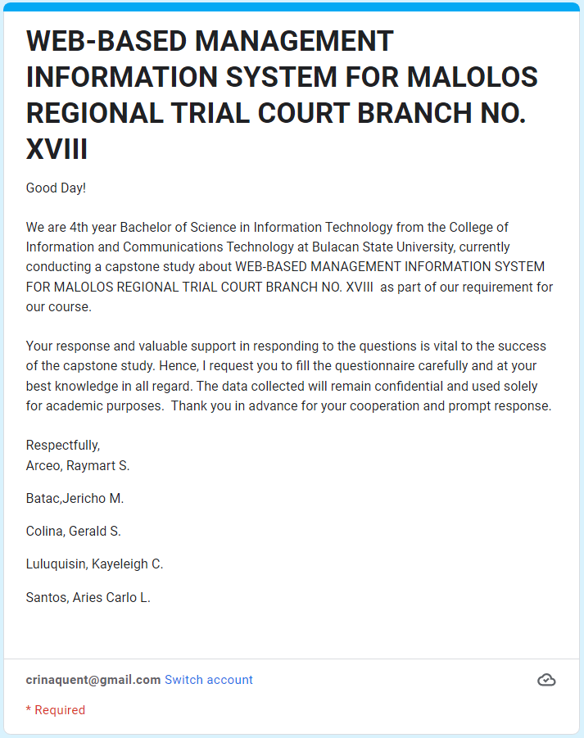

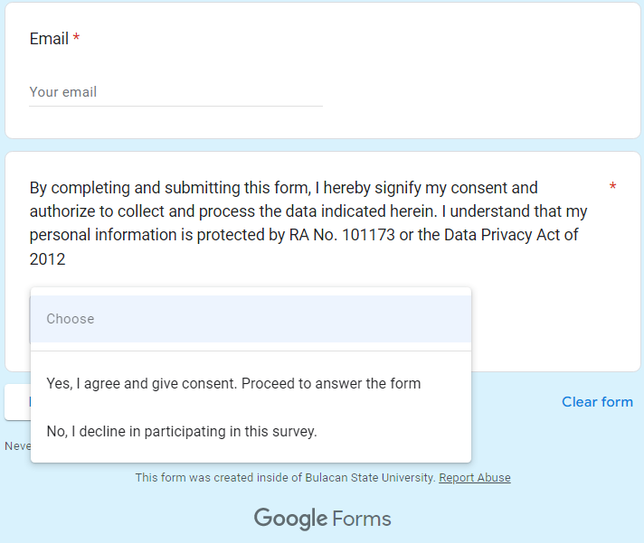 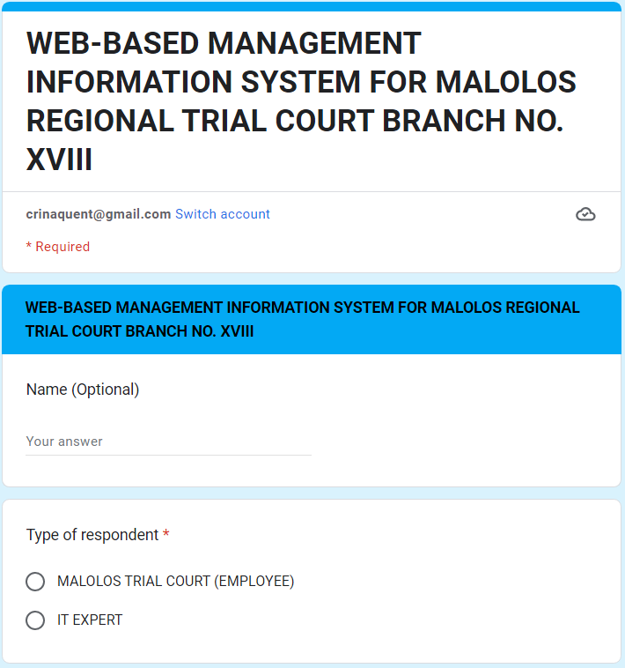

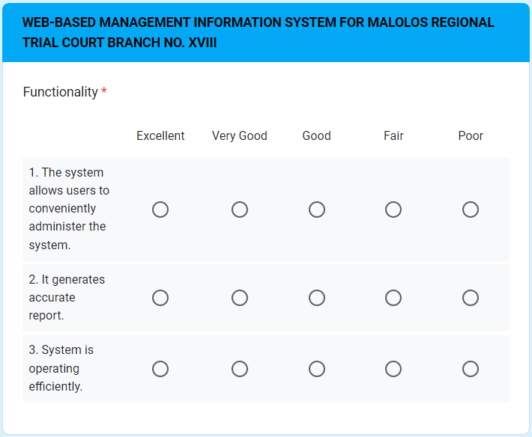 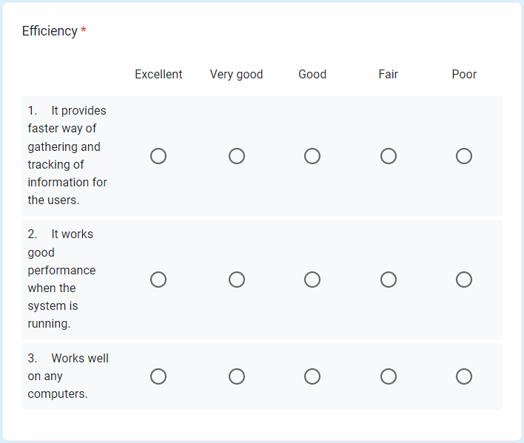 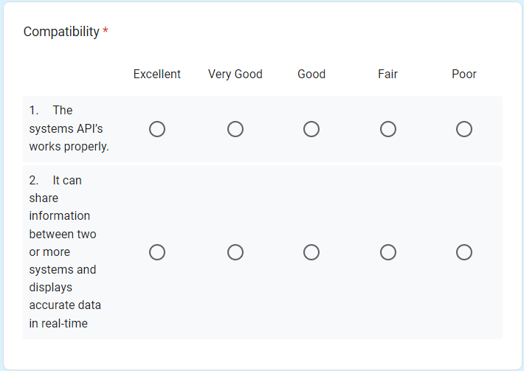 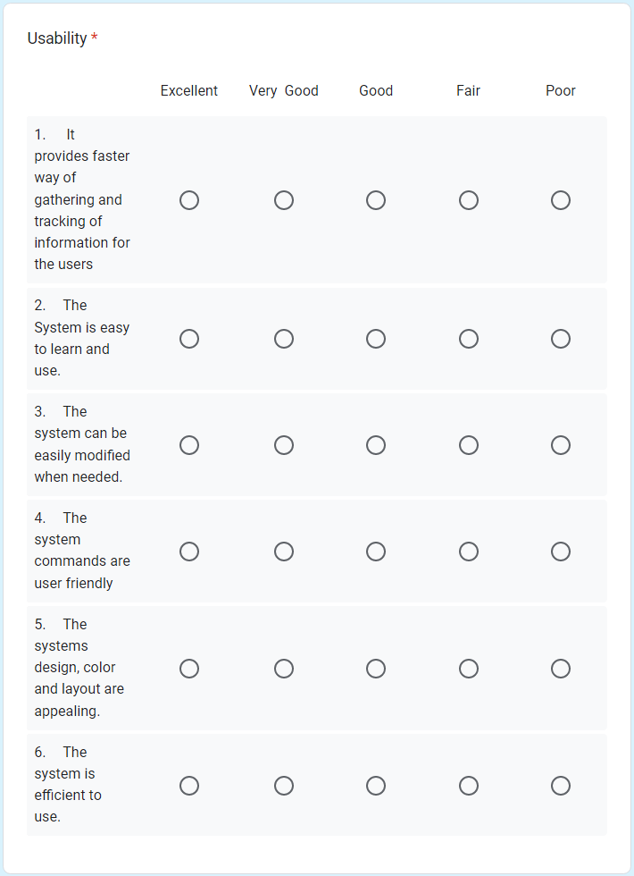 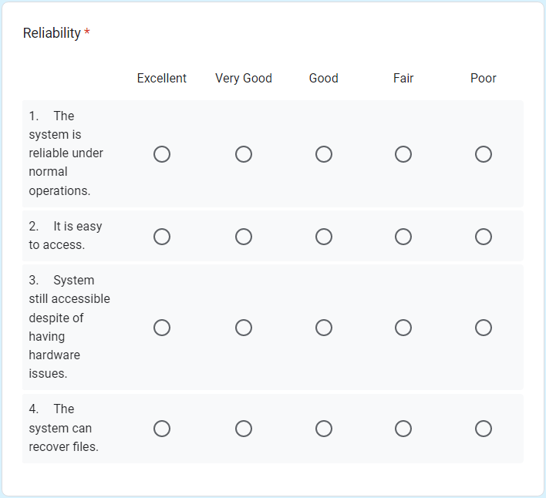 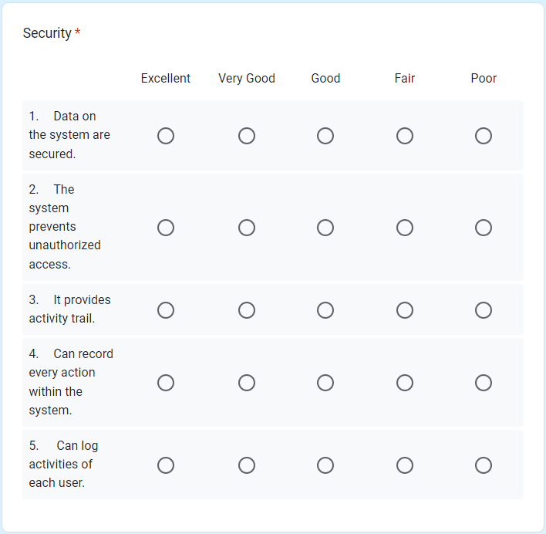 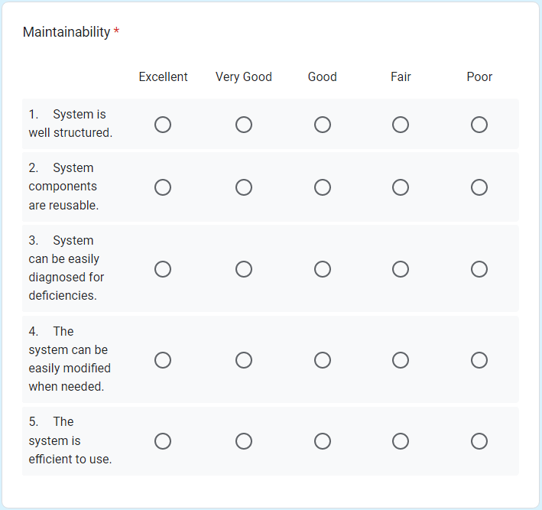 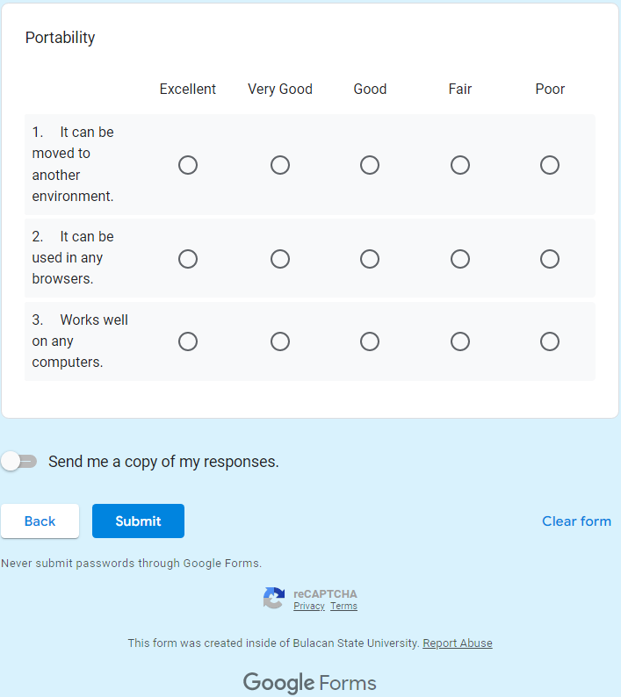

**Appendix D**

*Plagiarism Check Certificate*

**Appendix E**

*IMRaD Format*

**Appendix F**

*One-page Curriculum Vitae*

|  |
| --- |
| 922 Poblacion Pulilan Bulacan  09999650760  raymart.arceo.s@bulsu.edu.ph  Raymart S.  **Arceo** |
| **Objective**   |  | | --- | | Obtain entry level position to an established and company that would benefit from my improving technical knowledge and non-tangible skills and would help grow as a professional. | |

**Experience**

|  |
| --- |
| **2019**  **service crew,** chowking pulilan |

**Education**

|  |
| --- |
| **2010-2016**  **Junior High school,** Sta. peregrina high school |
| **2016-2018**  **Senior High School,** sta. peregrina high school   * With Honors |

**Skills**

|  |  |
| --- | --- |
| * JavaScript * Database and SQL * HTML/CSS * Python * C++ | * Analytical Thinking * Positive Attitude * Communication * Time Management * Patience * Collaboration |

**Activities**

I sometimes accept small software development projects

|  |
| --- |
| Jericho M.  **Batac** |
| **Objective**   |  | | --- | | To offer my present knowledge and abilities to the organization, as well as to learn new things and improve my skills through continuous learning and teamwork. | |

**Experience**

109 Cansinala Apalit Pampanga

09662285411

jericho.batac.m@bulsu.edu.ph

|  |
| --- |
| **2021-present**  **Computer Technician,** Kulot pisonet and printing shop |

**Education**

|  |
| --- |
| **2006-2012**  **Elementary,** Cansinala Elementary School  **2012-2016**  **Junior High school,** Cansinala National High School   * Vice President TLE club |
| **2016-2018**  **Senior High School,** La Consolacion University Philippines   * With High Honors |

**Skills**

|  |  |
| --- | --- |
| * Computer Hardware Specialist * Computer Literate * Computer Technician * Editing Software Literate | * Analytical Thinking * Positive Attitude * Good in Communication * Good in Time Management * Patience |

**Activities**

* Freelance Photographer

|  |
| --- |
| Gerald S.  **Colina** |
| **Objective**   |  | | --- | | Seeking a challenging position in a reputed organization where I can [learn new skills](https://www.mygreatlearning.com/academy/learn-for-free/courses/soft-skills-for-it?gl_blog_id=12201), expand my knowledge, and leverage my learnings. | |

**Experience**

0513 Sta.Ines ,Plaridel , Bulacan

09263643086

gerald.colina.s@bulsu.edu.ph

|  |
| --- |
| 2016 – 2018  **Service crew – Plaridel Mcdonalds** |

**Education**

|  |
| --- |
| **2006-2012**  **Elementary,** plaridel elementary school  **2012-2016**  **Junior High school,** dr.felipe de jesus national high school |
| **2016-2018**  **Senior High School,** Richwell Colleges inc. |

**Skills**

|  |  |
| --- | --- |
| * Computer Literate * Communication Skills * Flexibility * Teamwork * Problems Solving Skills |  |

**Activities**

Peer Tutoring

0699 Purok 5 San Miguel, Calumpit, Bulacan

09751548412

Kayeleigh.luluquisin.c@bulsu.edu.ph

|  |
| --- |
| Kayeleigh C.  **Luluquisin** |
| **Objective**   |  | | --- | | Secure a responsible career opportunity to fully utilize my training and skills, while making a significant contribution to the success of the company. A highly organized and hard-working individual looking for a responsible position to gain practical experience. | |

**Experience**

|  |
| --- |
| **2021**  **DATA ENCODER,** Atinito.ae  Describe your responsibilities and achievements in terms of impact and results. Use examples, but keep it short. |

**Education**

|  |
| --- |
| **2006-2012**  **Elementary,** st. anthony academy of bulacan   * Graduated With Honors   **2012-2016**  **Junior High school,** st. anthony academy of bulacan   * Graduated With Honors |
| **2016-2018**  **Senior High School,** La Consolacion University Philippines   * Graduated With Honors, Best Research, Best Researcher, Leadership Awardee |

**Skills**

|  |  |
| --- | --- |
| * Computer Literate * Database and SQL * HTML/CSS * Python | * Analytical Thinking * Excellent in oral and written communication * Resourceful in the completion of projects and effective at problem solving |

**Activities**

I do freelance and street photography and is also an active member of a public group called BulSU Capture inside the campus that aims to provide entertainment and acts as an influencer to each and every student.

|  |
| --- |
| Aries Carlo L.  **Santos**  0393 San Isidro 2 Paombong Bulacan  09387353305  ariescarlo.santos.l@bulsu.edu.ph |
| **Objective**   |  | | --- | | A highly motivated and hardworking individual looking for a responsible role to offer my present knowledge and abilities, as well as to gained a lot of new knowledge and improve my skills through continuous learning and teamwork. | |

**Experience**

|  |
| --- |
| **2018**  **librarian,** La Consolacion University Philippines  I organize library database and help people to find materials and resources. |

**Education**

|  |
| --- |
| **2006-2012**  **ELEMENTARY,** PINAGTULAYAN ELEMENTARY SCHOOL |
| **2012-2016**  **Junior High school,** San Pedro National High School  **2016-2018**  **Senior High School,** La Consolacion University Philippines |

**Skills**

|  |  |
| --- | --- |
| * JavaScript * Database and SQL * HTML/CSS * Java * Game Development | * Analytical Thinking * Problem-solving Capability * Communication Skills * Adaptability * Critical Thinking |

**Activities**

I often do some personal programming projects like websites, mobile games, and mobile applications.